1. What is a final framework for Sports Satellite Accounts?
- What classifications/correspondence tables are used for compilation of SSA?
Classifications used in RSS in Poland:
- PKWiU (which corresponds to cpa) classification of products, which includes products (raw materials, semi-finished products, final products as well as assemblies and parts) and services (activities provided to economic entities and the population, both for the purposes of production and consumption).
- PKD defines symbols, names and the scope of classification groupings at five different levels, ie sections, divisions, groups, classes and subclasses (national level).
The Polish Classification of Goods and Services (PKWiU), which was the basis for the selection of sports products, is compatible with the Polish Classification of Activities (PKD) for the first four classification levels, including the intermediate level, as the criterion for the division of products is their origin as defined by the PKD. Therefore, the division of products on these levels corresponds to the division of activities adopted in PKD.

- COICOP Classification of individual consumption by purpose is the basis for grouping household expenditure.
- Budget classification - classification of revenues, expenditures, revenues and expenditures and funds from foreign sources.
- Classifications – CN. The Combined Nomenclature is the list of goods that allows them to be classified for purpose:
- international trade, thus creating a system that allows for their proper identification,
- keeping foreign trade statistics,
- European Union and intra-community trade.

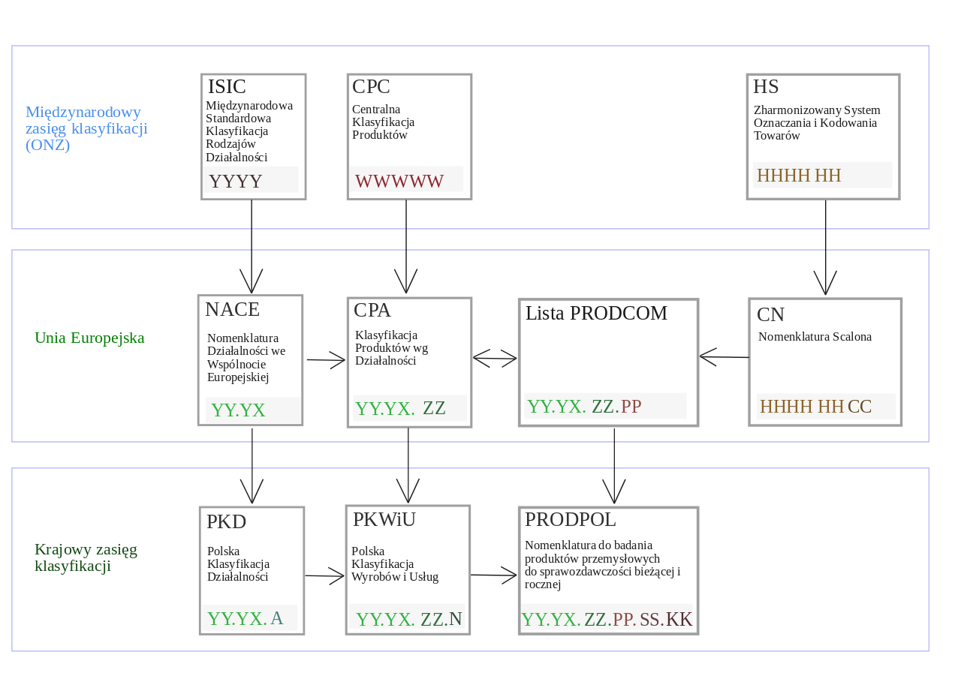
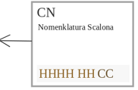
Relationship of statistical economic classifications

The above classifications are closely related and have transition keys.

- What are data sources (in case of Poland) for compilation of SSA?

RSS - data sources
- The primary source for calculating RSS items are input-output tables - supply and use tables compiled by the CSO in the National Accounts Department each year (January 2021 for 2017).
We use working tables arranged by 84 activities (head) into 543 product balance groups (side). Each balance group is assigned appropriate PKWiU codes. Using the transition keys, select the appropriate balance group that contains the PKWiU code you indicate and then, using available sources, determine what portion of the calculated item will affect the sport.

Additional sources are needed to expand the SSA position.

- household consumption. Final demand in terms of household consumption is determined on the basis of data from the household budget survey.
- In addition, we can use the data from the Participation in sport and physical recreation*. They are used to determine what part of household consumption is related to sports products distinguished in a given balance group. There are no international guidelines (standards) for this study.

- consumption of central and local government institutions.
The consumption of general government institutions is estimated on the basis of data from the supply and use tables based on reports on budget implementation in the section Physical education and sport (reports from the information system of the Ministry of Finance on reporting by public finance sector entities), reports on the implementation of the state budget expenditure plan prepared by the Ministry of Sport and Tourism, reports on implementation (specified in the budget act for a given year) of the financial plan of state earmarked funds: the Physical Culture Development Fund and the Sports Activities Fund for Students.
- employees.
For the calculation of employed persons by divisions of PKD, the source of data are tables prepared by the Labor Market Department. This data is obtained from surveys:
- Report Z-06, which includes legal persons and organizational units without legal personality as well as natural persons conducting business activity, in which the number of employees exceeds 9.
- 3 report covering legal persons and organizational units without legal personality as well as natural persons conducting business activity, employing up to 9 persons.

- SOF report covering people working in foundations, associations, political parties, social organizations, employers' organizations, economic and professional self-government.

- export and import
The primary data sources for calculating export and import in RSS are:
- data from supply and use tables,
- data from EXTRASTAT declarations (covering Poland's trade in goods with the so-called "third countries", i.e. non-EU Member States, based on customs declarations) and INTRASTAT (the system of statistics of Poland's trade in goods carried out only with EU Member States) *.
Data from the survey on international trade in services, that is:
- DNU-R Annual report on the international exchange of services,
- DNU-K Quarterly report on the international exchange of services.

- Other. Additionally, the RSS uses statistical data from the Annual Research on Economic Activity of Enterprises:
- SP Annual survey - national economy with a statistical number of 10 or more people.
- SP-3 Report on economic activity - the national economy with enterprises of 9 or fewer people. Representative observation method.

- How to select items corresponding to different definitions - Statistical definition/narrow and broad definitions ? How to identify shares output or expenditures for narrow and broad definition?

In Poland, a broad definition of sport was adopted as the basis for the calculation of the Sport Satellite Account.
Broad definition of sport: Statistical definition + narrow definition + all products and services which have a (direct or indirect) relation to any sport activity but without being necessary to do sport ("which draw upon sport as an input").
While classifying products and activities for the purposes of satellite sport account the importance of individual products in the Polish economy was taken into account. In the adopted
The adopted classifications do not include all items listed in the Vilnius Definitions of Sports because they were considered of little importance for the whole account, and the labor of compiling data for them would be incommensurably high compared with the quality result.
- How to compile the sport SUT? Is it constructed for each definition separately or for total Sport definition?
In order to construct the SUT, you need to select the relevant items from the Vilnius definitions that for your country you consider to be related to sport.
In Poland, tables are constructed for a broad definition of sport.
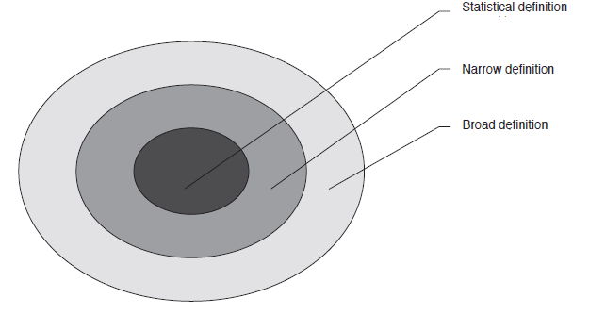
It is easy to extract the statistical definition as it contains the R 93 exemption.
- Which country may be considered as “the best practice” example for the compiling the SSA?
Among European countries, Austria and the United Kingdom played the role of pioneers in the creation of a satellite account of sport, and they were the first to present the results of national satellite accounts of sport.
A group of experts from SportsEcon Austria prepared a methodological document - How to create a satellite account of sport?, containing practical guidelines on methodology of creating satellite accounts. It contains practical guidance for countries developing satellite accounts for sport and at the same time it shows examples of solving some methodological problems which were applied in Austrian calculations.

