 |  |  | 

EU Twinning Project
IS12/ENP-APFI/08

Support to the Israeli Central Bureau of Statistics
in the development of National Accounts, Education Statistics, Survey Methodology, ICBS Website and
Coordination of Israel National Statistical System
Component C
Coordination of the Israeli National Statistical System

Activity C.2
Study visit on strategic planning and work plans

Implemented by:

Danny Pfeffermann, Government Statistician, ICBS
Yoel Finkel, Associated Government Statistician, ICBS
Tzahi Frankovitz, Head of Information and Statistics Department, Central Bank of Israel

Copenhagen
21-23 October 2013

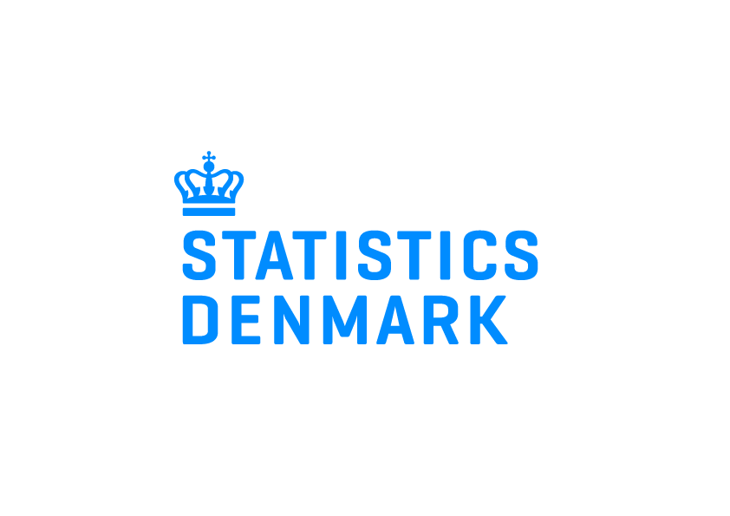 | 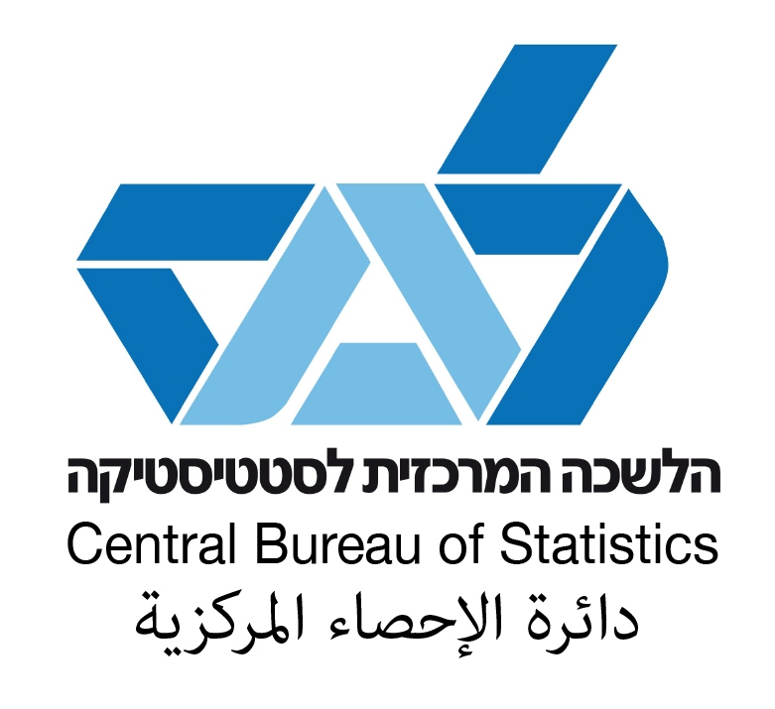

Table of contents
1 Summary 3
2 Background 3
2.1 Mandatory results of component C 3
2.2 Terms of Reference - purpose and expected output of C2 activity 3
3 Activity Results 3
4 Conclusions and Recommendations 3
5 Other Comments 3
6 Annexes 3
Annex C1.1 Programme 3
Annex C1.2 Persons met 3
7 Annexes external to the report: Presentations 3
Annex C1.3: Organisational Structure of Statistics Denmark 3
Annex C1.4: Contact with users of statistics 3
Annex C1.5: Micro-data and confidentiality 3
Annex C1.6: Implementation of the strategy 3
Annex C1.7: Work planning process 3
Annex C1.8: Dissemination strategy 3
Annex C1.9: Coherent Dissemination 3
Annex C1.10: The Law model 3
Annex C1.11: Cooperation with the Central Bank of Denmark 3
Annex C1.12: Coordination of data collection 3
Annex C1.13: Quality work in Statistics Denmark 3
Annex C1.14: Metadata work 3

List of Abbreviations
BC Beneficiary Country (Israel)
BoI Bank of Israel
ICBS Israel Central Bureau of Statistics
DS Statistics Denmark
MS Member State
NSS National Statistics System

1 Summary
The study visit to Denmark aimed to expose the Israeli senior directors to the experience accumulated in Statistics Denmark, when dealing with different aspects of strategic planning.
Senior directors of Statistics Denmark presented the organizational structure and the implication of implementing the strategic plan as a process of change. Integrated crucial parts of the process are the ongoing quality control and the reporting of metadata, including the quality of the end products.
The need for cooperation with the partners in the NSS is shared by both offices, and so is the centrality of the Central Bank. A visit to the Danish National Bank helped to the understanding of possible mechanisms to be operated in a mutual dependence situation.
The Danish dissemination strategy and implementation, including the relations with the users, and the way micro-data is made accessible to researchers, are well developed and can serve as a feasible and functional example for the development of ICBS website and micro-data accessibility.

2 Background
This study visit to Statistics Denmark took place as part of the project component that addresses planning and management issues on the organizational level. It was the second activity out of six, in which Statistics Denmark support ICBS in planning strategic plan for ICBS and in defining and coordinating the NSS partners and statistical products.

2.1 Mandatory results of component C
MR13: Establishment of a long-term strategic plan for Israeli official statistics
MR14: Establishment of a system and procedures for long- and short term planning
MR15Enhancement of ICBS engagement in the NSS

2.2 Terms of Reference - purpose and expected output of C2 activity
The purpose f the activity is to share the experience of Statistics Denmark in strategic planning, including development of work plans and follow-up mechanisms.
The expected output from the activity is a study visit report with lessons learned, in particular regarding the Danish strategy on statistics and its development; monitoring mechanisms including work plans.

Specific subjects to be elaborated
- Organisational Structure of Statistics Denmark
- Contact with users of statistics
- Micro-data and confidentiality
- Strategy work in Statistics Denmark
- Statistical Programme
- The Law model
- Cooperation with the National Bank
- Administration of Statistical Business Register
- Cooperation with the Ministry of Education
- Coordination of data collection
- Quality work in Statistics Denmark
- Metadata work in Statistics Denmark

Activity Results
3.1 The Organisational Structure of Statistics Denmark
- Statistics Denmark is located in the Ministry of Economic Affairs and the Interior.
- Board of Directors: Chairman: the National Statistician + 6 members with insight into social and economic conditions, decides on work-plan and budget. Meets 4 times a year.
- Board: National Statistician, 5 directors and Head of Management office, meets once a week.
- Overall Management: Board + 34 heads and deputy heads of divisions. Meets according to needs.
- There are 9 Advisory Users Committees.
- Five Departments: Social Statistics, Business Statistics, Economic Statistics, Sales and Marketing, User Services.
- General Management and international activities were prioritized.
- There is a mix of Process-oriented and Subject oriented organization.
  - Contact with users of statistics
- Strategic objectives for dissemination: Enhance SD’s knowledge of user needs, improve dissemination, including intelligibility and documentation, enhance the competence of users of statistics, increase the use statistics – both free and paid, have satisfied users
- SD works with several users committees in the subjects of: Labour market statistics, Population statistics, Food statistics, Welfare statistics, Knowledge statistics, Economic statistics, Local authorities, Researchers, Data reporters.
- The members of the committees are representatives from ministries, the central bank, other public organizations, and research institutes.
- They meet twice a year and discuss users’ needs, evaluate the statistical program, evaluate quality of documentation and dissemination.
- These groups are important for getting the involvement of the users.
- Matrix of main users’ groups and main products:

 | Experienced users | Students | Media | Public | Researchers
Publications
Stat Bank
Web
Meta data
Courses
Sale: Statistics
Sale: Microdata

  - Micro-data and confidentiality
- Data for research handled by a specialized Research Service Unit, 17 people.
- There are 768 active projects at the research machines and 1,400 active researchers.
- Only researchers from authorized institutions can get access to micro-data. They have to belong to a stable institution with a manager in charge, and with a group of researchers/analysts.
- Authorized institutions can be from the public sector, the private sector; foreign researchers have to be attached to a Danish institution in order to get authorisation.
- Most data used are from administrative registers that have been processed for statistics. Infrastructure linked registers are: Population, Dwellings and Businesses.
- The research servers are separated from the rest of the servers at Statistics Denmark

  - Strategy work in Statistics Denmark
- Implementing a strategy is changing the organization and therefore it should be owned by the top management, and its goals and expected outcome should be communicated internally and externally.
- Human resources and technology are pre-requisites.
- Implementation of work plans in SD is managed by contracts between all levels; from the Ministry to the divisions. It is a safeguard for better management, focus on central issues, working towards common goals and involvement of the employees.
- Performance indicators are measured vis-à-vis the strategic goals and work-plans.

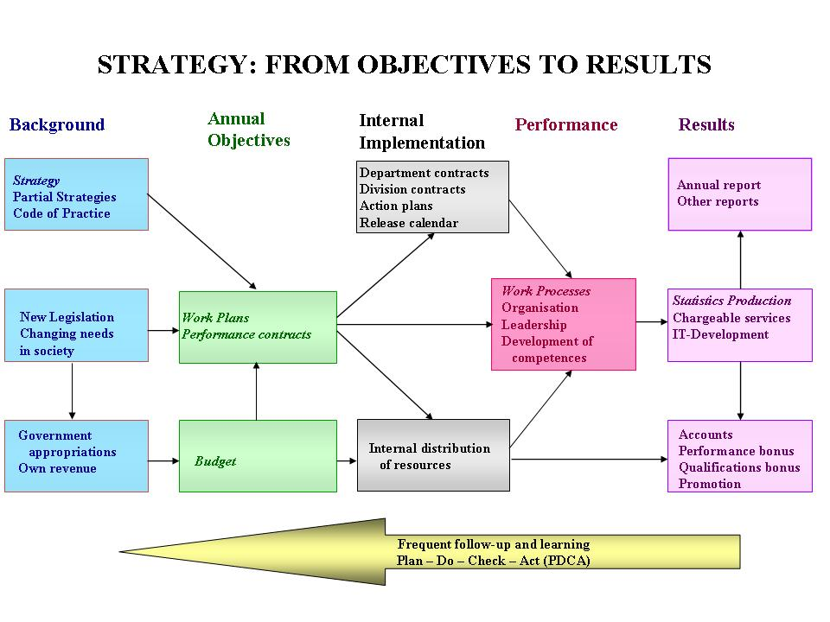
  - Statistical Programme
- Budget of 53 million euro: 68% financed by the government appropriation, 14% by co-financed projects, 17% by customers paying full cost and 1% by publications. 562 full-time equivalent employees. Cost of a man-year is about 100,000 euro including overheads. Charge for work done for external users is 130,000 euro including overheads for commissioned work.
- The distribution of the allocated budget is done by Statistics Denmark according to the needs of society in general and of the government, and according to strategic conditions.

  - The Law model
  - Statistics Denmark has developed an econometric model to estimate the effects of contemplated legislation. It contains micro data on a sample of the population
  - It is used by the Ministry of Economic and Internal Affairs and authorized staff of different government departments.

  - Cooperation with the National Bank
- The cooperation is anchored in a Framework Agreement for cooperation, that was signed in 2001 (It is currently being revised)
- The main goals of the agreement were: to define a division of responsibilities and tasks related to data reporting to the international organizations, and to formalize and enhance cooperation - in order to answer growing demand for economic and financial statistics, and to improve efficiency and quality of the statistics produced.
- There is a committee for cooperation and four sub-committees: Balance of Payment, Dissemination, Business register, Financial accounts. There is also ad-hoc cooperation on BoP regarding the implementation of BPM6.
  - Administration of Statistical Business Register (SBR)
  - The SBR is one of three basic registers linked by unique identifiers, Personal Identification number (PIN), ID of enterprise and local unit, ID of building and access address and address-code. The linkage provides: Owner-employees PIN and Owners-resident PIN.
  - Uses of the SBR are: Live/Frozen register, background variables for surveys, Enumeration, stratification and sampling of all business statistics, business demography, control of response burden.
  - Data sources and user interfaces of the SBR:
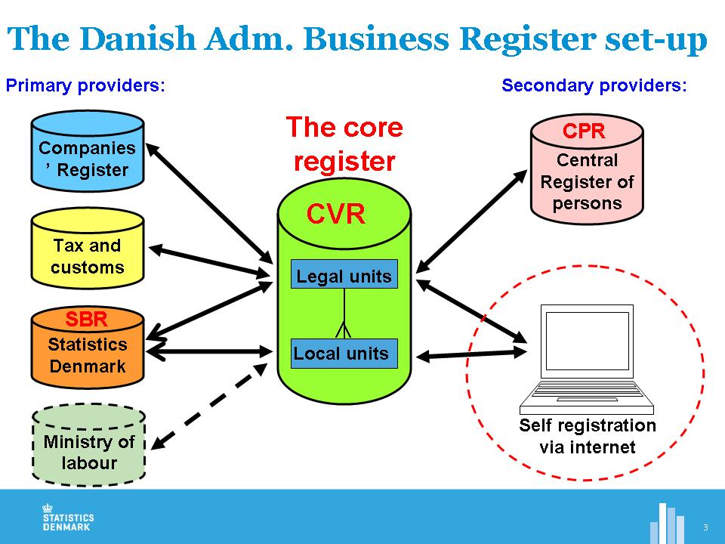

  - Cooperation with the Ministry of Education
  - Formal cooperation in order to be able to produce sequential register and to enable the Ministry to access these data. The register covers “education from cradle to grave”.
  - Informal cooperation in seminars and visits in education institutions, contributes to faster data production, adoption of ISCED, new publications, better insight and more information about the production process (input to quality control).
  - There is also a potential conflict of interests when asking who is in charge? On what terms can the ministries use SD data? Who will gather and control the data? Does ‘money talk’?

  - Coordination of data collection
- There are 90 mandatory business related surveys and 10 voluntary ones with 65,000 respondents. 17 surveys comprised by mandatory digital reporting. Transition is made from stovepipe model to centralized, standardized digital data collection systems.
- There are 8 permanent interview surveys and additional three household surveys. Social statistics in general is mainly register-based statistics, the surveys are voluntary. Methods for questionnaire design, sampling, imputation, etc. are standardized.
- Reorganization of business statistics implied moving from 10 to 5 units, central Data Collection and Methods Unit, Business Registers Unit, and Units for statistical processing served by functional units.
- The major new initiatives are: Plan and time-table for coordination of data collection, plan for transfer of a number of new statistics every year to central unit, new team for central questionnaire design – standardization, New IT-measures for questionnaires, common digital processes – away from paper and telephone, integration of business registers.
- Overall, there is an acceptance and recognition of the benefits of the re-organization. But, for specific surveys stove pipe systems are still used, the expected savings have not been fully realized and the change of the data collection organization took almost 10 years.

  - Quality work in Statistics Denmark
- Guidelines worked with are: UN Fundamental Principles of Official Statistics, European Statistics Code of Practice, EU Quality Assurance Framework.
- In the strategic plan for 2015 high priority was put on quality of statistical products; quality of processes and quality of content. Quality is translated to Fitness for use.
- Adhering to quality objectives is imposed from the top, with visual and constant top management attention, and workshops.
- There is a daily struggle for resources.

3.12 Metadata work in Statistics Denmark
- SD follows best practices from METIS (UNECE working group). Yet, there are many problems in fulfilling user-needs in a cost-effective way: The work-processes is fragmented and non-standardized, the metadata is linked to the final data only, the presentation of metadata is fragmented and incomplete, the concepts database is incomplete, classifications and code-lists are decentralized.
- SD is engaging standards in order to overcome the above problems: Generic statistical business Process Model (GSBPM), SIMS, SDMX (ESQRS and ESMS) from Eurostat, DDI and DDI-tools to ensure integrated metadata.

Conclusions and Recommendations
  - The Israeli governmental system works along different lines of budget management, i.e. ICBS cannot adopt the Danish model although desirable. However, the possibility of ownership of the production of core official statistics has been explored and direct rather than indirect funding (through other Ministries) is looked for.
  - Within the framework of the twinning, and with the help of the Danish experts, ICBS has defined a list of 12 topics to serve as the strategic plan areas:
      - Dissemination of information
      - Quality objectives
      - Information Security and Data Confidentiality
      - Development of Statistics
      - Census
      - Coordination of the National Statistical System (NSS)
      - Communication with Providers of Information
      - International Involvement
      - Technological Infrastructure
      - Efficiency Objectives
As for the way implementation of further elaboration and objective goals setting for the whole organization, a reference person will be selected from each department and a 1st version of their input will be drafted by the end of the third quarter.
  - ICBS has decided to adopt the European Statistical CoP. Moreover, in the framework of re-visiting the Statistical Ordinance, a designated committee, led by the former deputy Governor of the Bank of Israel, Prof. Eckstein, will look into the UNCS recommendation to introduce the UN Fundamental Principles of Official Statistics to the statistics law in all countries. As for the implementation and quality assessment plan, a senior staff member of ICBS was nominated to be in charge of the subject.
  - Users-orientation approach is to be further developed in ICBS. First steps implemented in the tendering of the new website and in the recognition of the importance of dissemination in the organization by including the manager of the information unit in the management of ICBS. Furthermore, a new committee, chaired by Prof. Avia Spivak, from Ben-Gurion University of the Negev, is defining a statistical portal to include data produced by the main official statistics producers: ICBS, the National Insurance Institute, Bank of Israel, Ministry of Finance and more.
  - Additional aspect of dissemination is the accessibility of micro-data. ICBS is in a process of forming a designated unit in the Chief Scientist Department, with specific goals to improve the service given to researchers, in all aspects; the professional, the logistics and the working environment. Furthermore, the Eckstein committee will address the issue of micro-data and the possible need to revise the Statistical Ordinance.

Other Comments
We would like to thank Statistics Denmark for the very efficient, functional and pleasant visit. Sharing experience and discussing obstacles shared by most members of the international statistics community, widens the options for creative and fruitful solutions.
6 Annexes

Annex C2.1 Programme
Day 1: 21 October 2013
9.30-10.30 Arrival, welcome and introduction
Lars Thygesen, Director, Sales and Marketing
10.30-11.30 Organisational Structure of Statistics Denmark
Kirsten Wismer, Director, Economic Statistics
11:30-12:00 Contact with users of statistics
Kirsten Wismer, Director, Economic Statistics
12:00-12:30 Micro-data and confidentiality
Charlotte Nielsen, Senior Adviser, Research Services
12.30-13.30 Lunch break
13.30-14.30 Implementation of the strategy
Bo Johansen, Chief Adviser, Management Office
14.30-15:30 Work planning process
Bo Johansen, Chief Adviser, Management Office
15.30-16:00 Dissemination strategy
Annegrete Wulff, Head of Dissemination
Day 2: 22 October 2013
9.30-10.30 The Law model
Mikael Kirk, The Law Model; Lars Thygesen, Director, Sales and Marketing
10.30-11.30 Cooperation with the Central Bank of Denmark (Danmarks Nationalbank)
Kirsten Wismer, Director; Casper Winther, Head of Balance of Payments
11:30-12:00 Administration of Statistical Business Register
Birgit Nielsen, Head of Section; Vibeke Skov Møller, Chief Adviser, Business Registers
12:00-12:30 Cooperation with the Ministry of Education
Christian Vittrup. Chief Adviser, Education Statistics
12.30-13.30 Lunch break
Jørgen Elmeskov, National Statistician
13.30-15:00 Visit to the Central Bank of Denmark (Danmarks Nationalbank)
15:00- Sightseeing in Copenhagen

Day 3: 23 October 2013
9.30-11.00 Coordination of data collection
Hilmar Bojesen, Director, Business Statistics
11.00-12.30 Quality work in Statistics Denmark
Lars Thygesen, Director, Sales and Marketing
12.30-13.30 Lunch break
13.30-15.00 Metadata work
Lars Thygesen, Director, Sales and Marketing; Mogens Grosen Nielsen, Methodology
15.00-15.30 Conclusions, final discussion and evaluation
Lars Thygesen, Director, Sales and Marketing

Annex C2.2 Persons met

Lars Thygesen, Director, Sales and Marketing
Kirsten Wismer, Director, Economic Statistics
Charlotte Nielsen, Senior Adviser, Research Services
Bo Johansen, Chief Adviser, Management Office
Annegrete Wulff, Head of Dissemination
Casper Winther, Head of Balance of Payments
Birgit Nielsen, Head of Section, Business Registers
Vibeke Skov Møller, Chief Adviser, Business Registers
Christian Vittrup. Chief Adviser, Education Statistics
Jørgen Elmeskov, National Statistician
Hilmar Bojesen, Director, Business Statistics
Mogens Grosen Nielsen, Methodology and Metadata
Danmarks Nationalbank

7 Annexes external to the report: Presentations

Annex C2.3: Organisational Structure of Statistics Denmark

Annex C2.4: Contact with users of statistics

Annex C2.5: Micro-data and confidentiality

Annex C2.6: Implementation of the strategy

Annex C2.7: Work planning process

Annex C2.8: Dissemination strategy

Annex C2.9: Coherent Dissemination

Annex C2.10: The Law model

Annex C2.11: Cooperation with the Central Bank of Denmark

Annex C2.12: Coordination of data collection

Annex C2.13: Quality work in Statistics Denmark

Annex C2.14: Metadata work

Annex C2.15: Micro-data and confidentiality

Annex C2.16: Quality work at Statistics Denmark

Annex C2.17: The Work Planning Process and the Resources

