Exercise 2: Simple Seasonal Adjustment with JDemetra+

- Open JDemetra+
- Import your data file (Exercise_2.xls)
  - Either by right-clicking on “Spreadsheets” and selecting “open”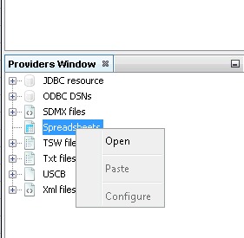
  - Or by dragging and dropping your data file onto “Spreadsheets”
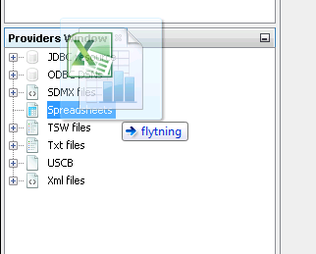
- If the data file doesn’t have the right format, you won’t be able to see any time series
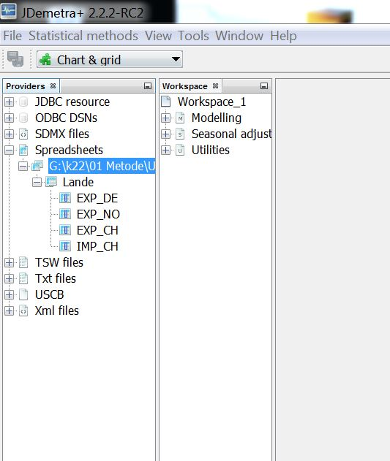
- If the data file has the right format, you’ll see the time series when you expand the view (there are four time series)

- When double-clicking on a time series, you’ll see the graph in the right hand side window. Look at the graphs for each time series and assess whether there’s seasonal variation or not.

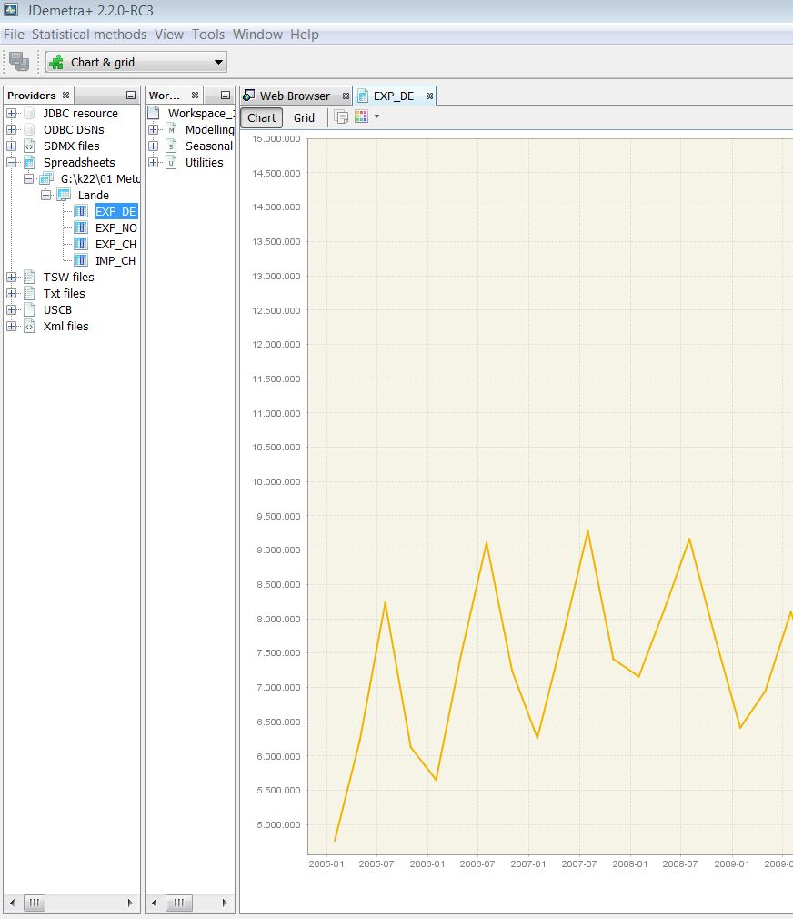

- Carry out a seasonal adjustment by following the steps below.

- Select ”Statistical methods” from the top menu, then “Seasonal adjustment” -> “Multi Processing” -> “New”.

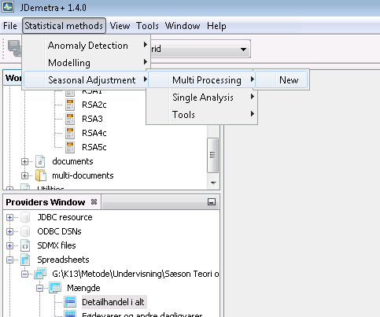

- Select seasonal adjustment specification file X13 – RSA5C as shown below. This has to be done before selecting your data.
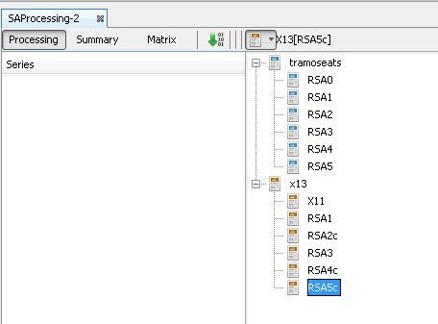

- Now you’re ready to drag and drop the time series to be seasonally adjusted onto the seasonal adjustment window (SAprocessing-1).

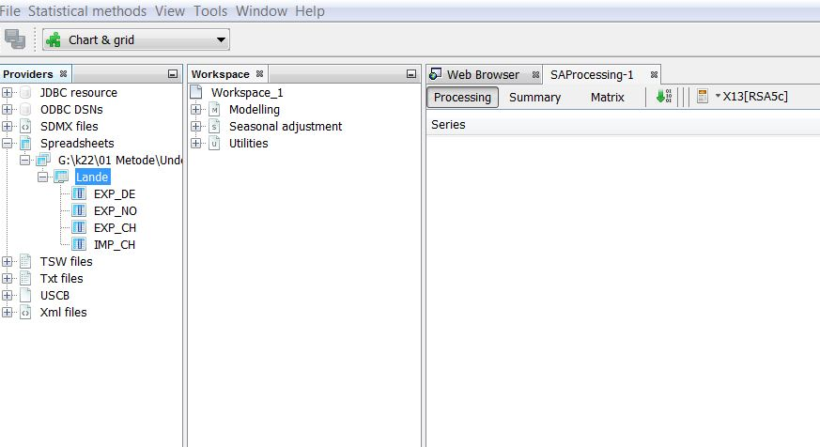

- When the time series show in the “SAProcessing-1” window, click on the green downwards arrow in order to run the seasonal adjustment.
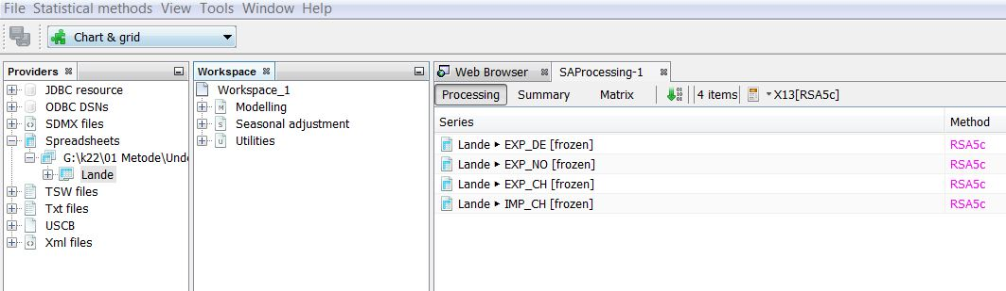

- Now, you can see the seasonal adjustment results for each time series by selecting it in the “SAProcessing-1” window. Select the four time series in turn and assess is there’s seasonal variation by selecting “Main results”, then expanding the view and selecting “Charts” and looking at both “Sa, trend” and “Cal., sea., irr”. See screenshots below.
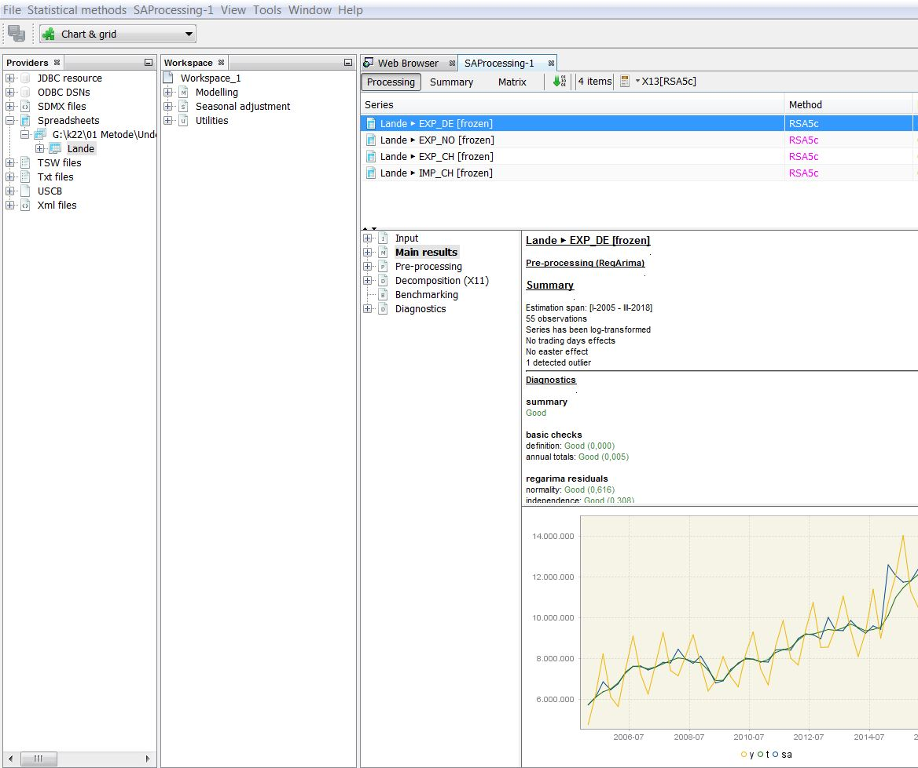

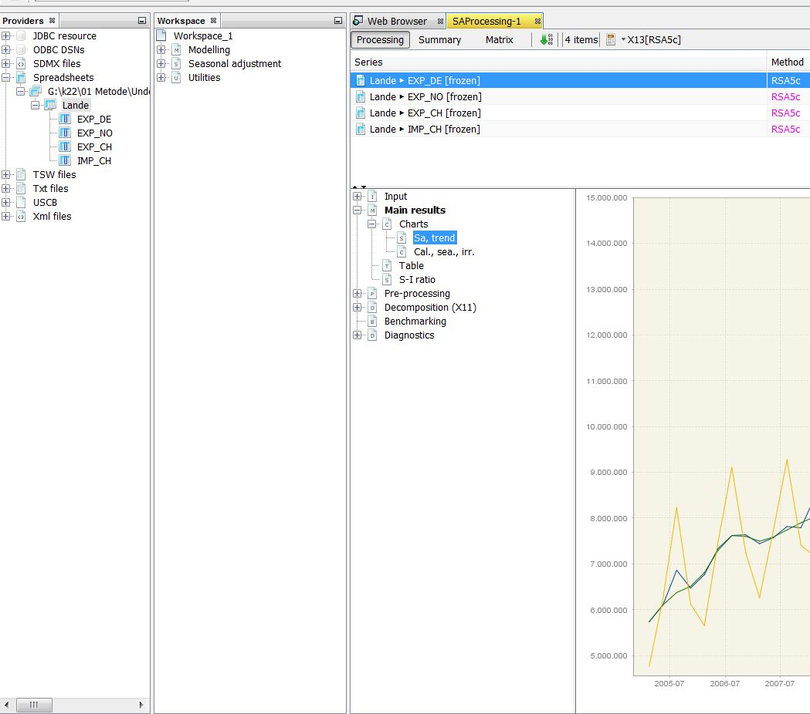

- A number of tests for significant seasonality are carried out when running the seasonal adjustment. The most important are found under diagnostics:
- Select “Diagnostics”, expand the view and select “Seasonality tests”, then expand the view again and select either “Original (transformed)” or “Combined test”

Do these test results correspond to your visual assessment of seasonality?
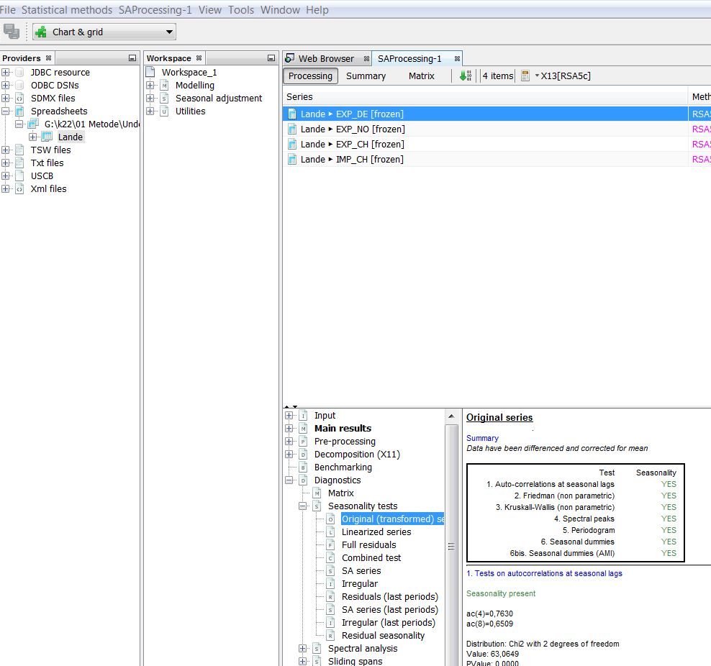

Exercise 3
- Import the data file Exercise_3.xls (see Exercise 2 for instructions on data import).
- Assess visually which preadjustments are relevant for the two time series “svin i alt” and “Hotelovernatninger”.
- Are these preadjustments temporary and/or permanent?
- Carry out an automatic seasonal adjustment as in Exercise 2.
- Click on a time series and select “Pre-processing” as shown in the picture. Under “Summary” you’ll see which preadjustments have been carried out.
- Which preadjustments have been carried out, and do they agree with your visual assessment?

