Simple Seasonal adjustment (series with clear, seasonal variation)

Adjust the excel file
An excel file has to be in a specific format for JDemetra+ to be able to import the data. Otherwise, the spreadsheet (Under “Providers -> Spreadsheets”) will show up as if it’s empty, or possibly just the time series will appear empty of data.

- Delete rows and columns so that your data area starts in the top left corner. The time series can either be recorded vertically or horizontally. The date column can either be the first or the last row/column.
- Adjust the date format. It has to be an actual date format and not a user-defined one. It can either be set using the “format cells” option in Excel or by using the Data format option in the Data source window when importing the data (see 2.3.b below)
- Empty cells are interpreted as missing values, no matter whether they are at the beginning, the middle or the end of a period. So if some series have fewer observations i.e. starting at a later point than other series they will have missing values ontil there starting point. Seasonal adjustment of these shorter series will be made from the actual starting date.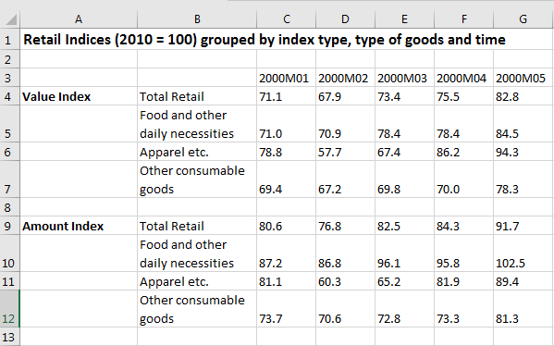
- The format above with two columns with time series names is not valid for JDemetra+. You’ll have to make two data sheets, one for Amount and one for Value or you can rename the series names for value and amount so thy have different names
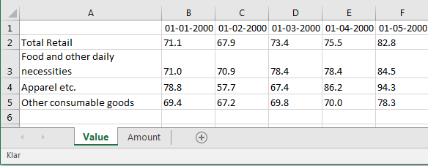
- Save the file, either as .XLS or as .XLSX

Import your data
- Open JDemetra+
- Import your file. In order to import data from a source, you have to click on that type of source in the Providers window. Choose Spreadsheets as we’re working with an Excel file, then Open.
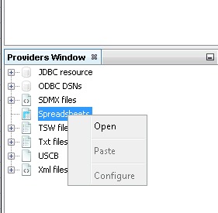
- The Open data source window gives you the following options:
  - Spreadsheet file – the path for the excel file
  - Data format – used to read in dates and formats. It has three fields: locale (country), date pattern (date format e.g. YYYY-MM-DD), number pattern (meta format for numerical values, e.g 0.## means two decimals)
  - Frequency – time series frequency. Can be undefined, annual, half-annual, four monthly, quarterly, bi-monthly or monthly. If you don’t provide a frequency, JDemetra+ will analyse the data in your input file and select one.
  - Aggregation type – type of aggregation in your data file. This can be: None, Sum, Average, First, Last, Min or Max. Aggregation can only be carried out if the frequency parameter is specified. E.g. if frequency is set to quarterly and aggregation is set to Average, a monthly time series will be transformed into a quarterly time series by taking averages within each quarter.
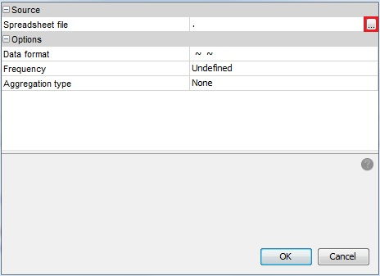

- Select ”….” in the source section in order to open the file (the button marked by a red box above). Select a file and click ”OK”
- Now you can specify Data format, Frequency and Aggregation type. It’s not mandatory and in this example, we don’t specify anything.
- Alternatively, you can import a data file from Windows Explorer by dragging and dropping it onto Spreadsheets and click OK:
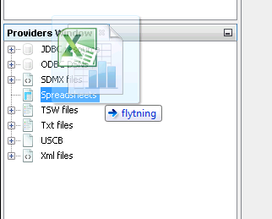
- Data is organised in a ”tree structure”
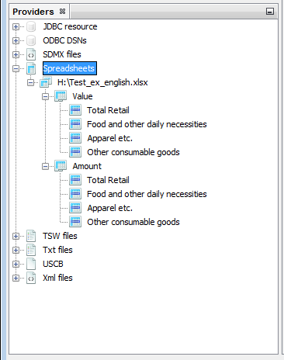

Inspect Your Data
- In order to see the graph of a time series, right click on it in the Providers Window and choose “Open with -> Chart & grid”
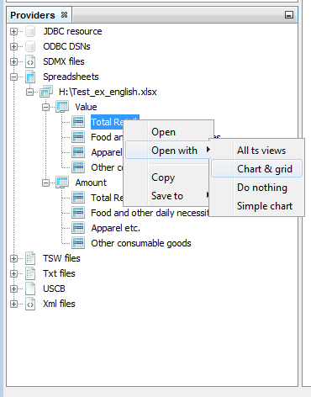
The graph is shown in the panel on the right (unless you’ve changed the layout). You can see the series as a table instead by choosing Grid instead of Chart in the top left corner of the window (red box) 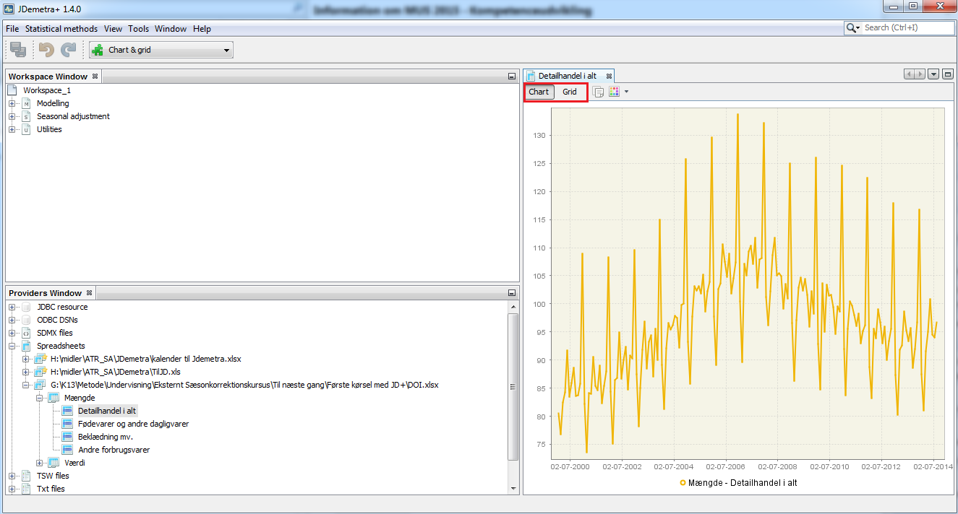

- By using the local menu, you can adjust the design of the graph, save or copy. The local menu is found by right clicking anywhere in the Chart area.
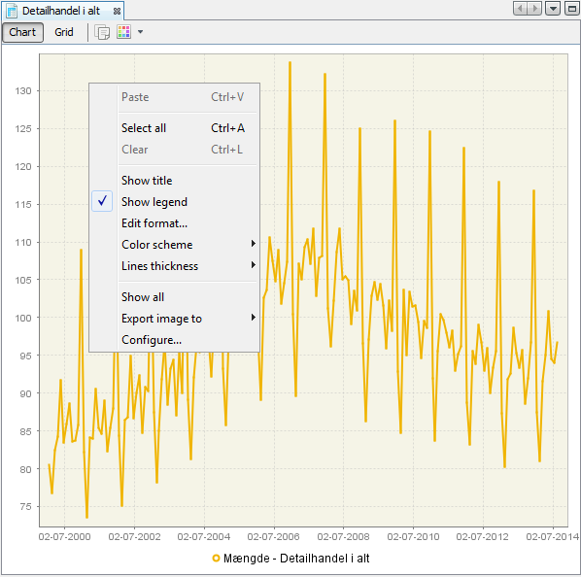
- When you select the time series (by clicking on it) and the right clicking, you get more options:
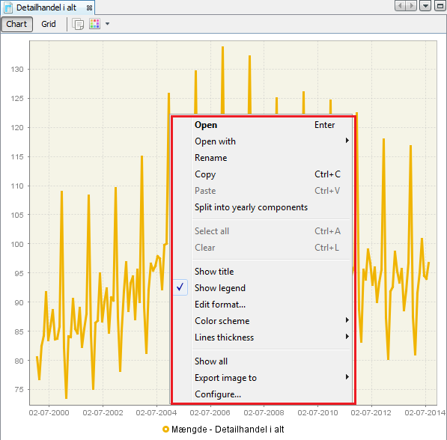
- Among these is Open with, which will open the time series in a separate window. A very useful feature is the “Split into yearly components”. This will open a separate window showing a line for each year of the time series. Comparing the time series year by year makes it easy to see if there’s a clear, seasonal pattern.
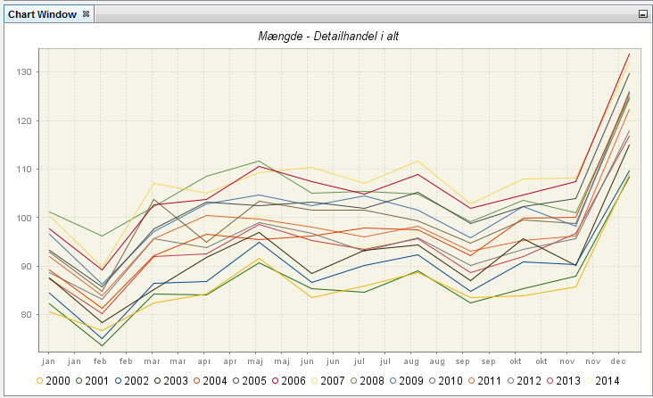
Here, we see a very clear, seasonal pattern for retail sales. This is obvious from the graph of the raw retail data, too, but some time series do not contain an equally clear pattern. There is an increase in December of each year, and a decrease in February.

Automatic Seasonal Adjustment
- In order to start a seasonal adjustment process (SA-process), go to the top menu and select Statistical methods → Seasonal adjustment → Multi Processing → New
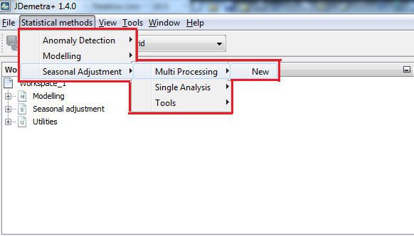
- This opens an empty window (default name: SAProcessing-1). The default specification is TS[RSA4]. In Statistics Denmark, we normally use the X12 method and its extensions, so we choose X13-RSA5c. This is done by clicking the button marked in red below:
- And then choosing from the drop-down menu:
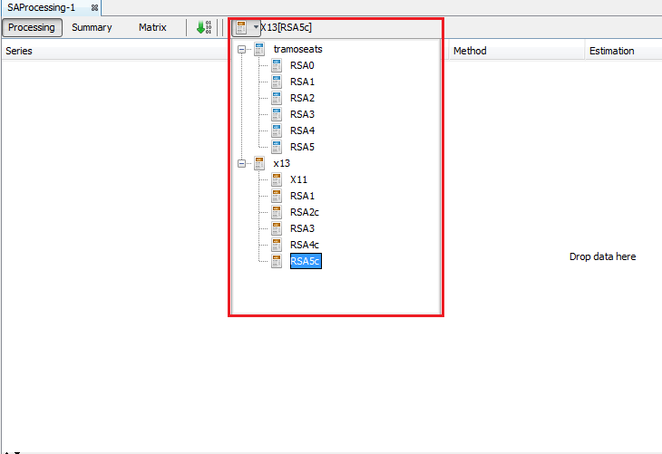

- The various specification options are described here:
X11 | No pre-adjustment
RG0 | - Airline model (011)(011)
RSA1 | - Automatic transformation  - Automatic outlier detection  - Airline model (011)(011)
RSA2c | - Automatic transformation  - Automatic working days adjustment  - Automatic Easter adjustment  - Automatic outlier detection  - Airline model (011)(011)  - Automatic pre-adjustment for leap year
RSA3 | - Automatic transformation  - Automatic outlier detection  - Automatic model selection
RSA4c | - Automatic transformation  - Automatic working days adjustment  - Automatic Easter adjustment  - Automatisk outlier detection  - Automatic model selection  - Automatic pre-adjustment for leap year
RSA5c | - Automatic transformation  - Automatic trading days adjustment  - Automatic Easter adjustment  - Automatic outlier detection  - Automatic model selection  - Automatic pre-adjustment for leap year

- You can now Drag and Drop the time series to be seasonally adjusted from the Providers window to the SAProcessing window. You can either specify separate series or the whole dataset. You can even select the same time series multiple times in order to compare different models (you can later change the model specification by clicking the “Specifications” button in the top right corner of the SAProcessing-1 window).
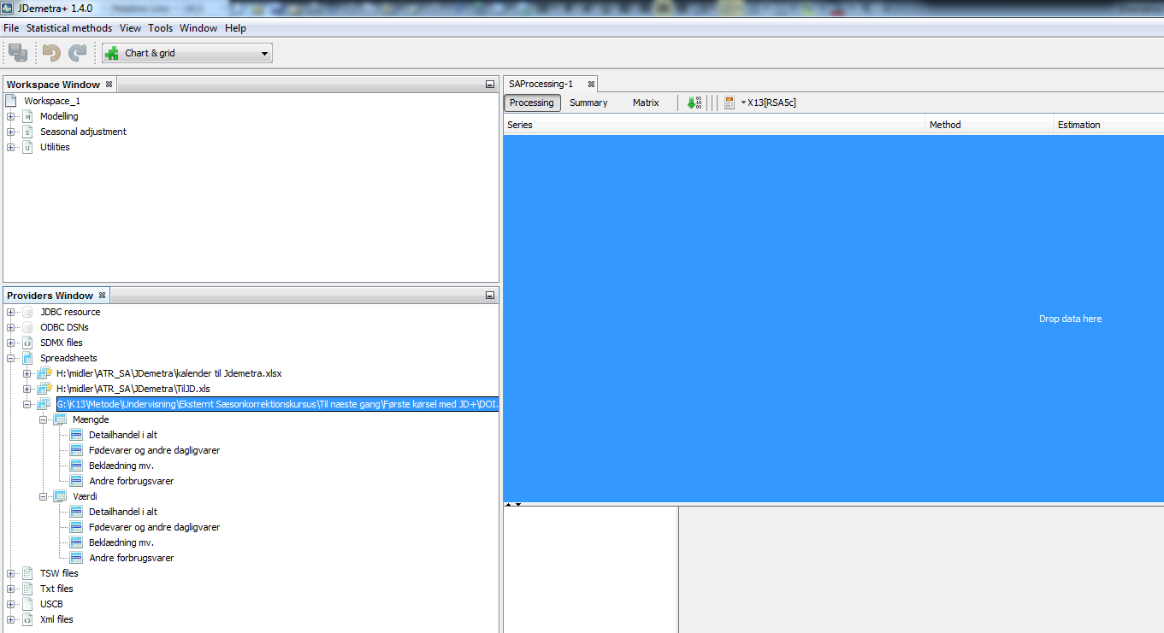

- The seasonal adjustment is not carried out as soon as the time series are dragged into the SAPricessing-1 window (This is shown by: Status – ”Unprocessed” as well as missing values in Quality and Warnings). The adjustment is carried out when you select the green arrow (see below). For new time series, the Estimation column defaults to Concurrent, which means that no earlier seasonal adjustment results for the time series are used in the model estimation (since they don’t exist yet).
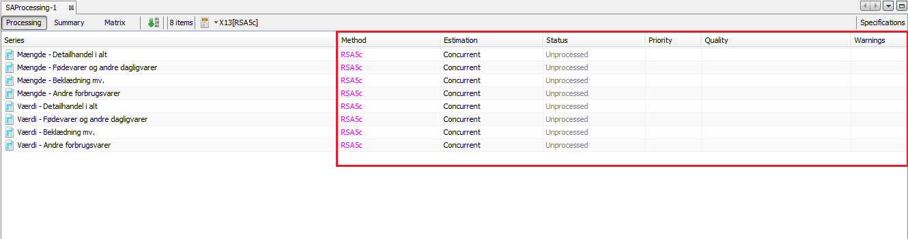

- When you click the green arrow button marked in a red box below, the seasonal adjustment is carried out. The Status (of the time series adjustment) is updated and the quality of the seasonal adjustment (Quality) as well as any possible warning are filled in (Warnings).
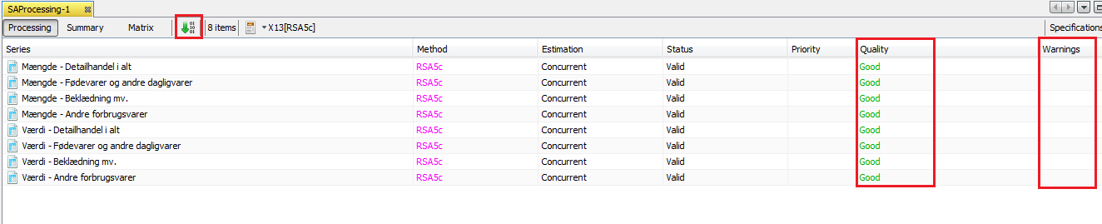
There are no automatically detected issues (no exclamation marks in the Warnings column). The quality of the estimation for all these time series is ”Good”.

- When you click on any specific series in the SAProcessing window, detailed results are displayed below the SAProcessing panel. By default, it displays a résumé of the seasonal adjustment results as well as two graphs (see below): The raw data, seasonally adjusted series and trend-cycle on the left and SI ratio values on the right (The blue line represents the seasonal factors, the red line is the seasonal averages and the dots are the SI-ratios – generally speaking, you want the dots at be as close to the blue line as possible).
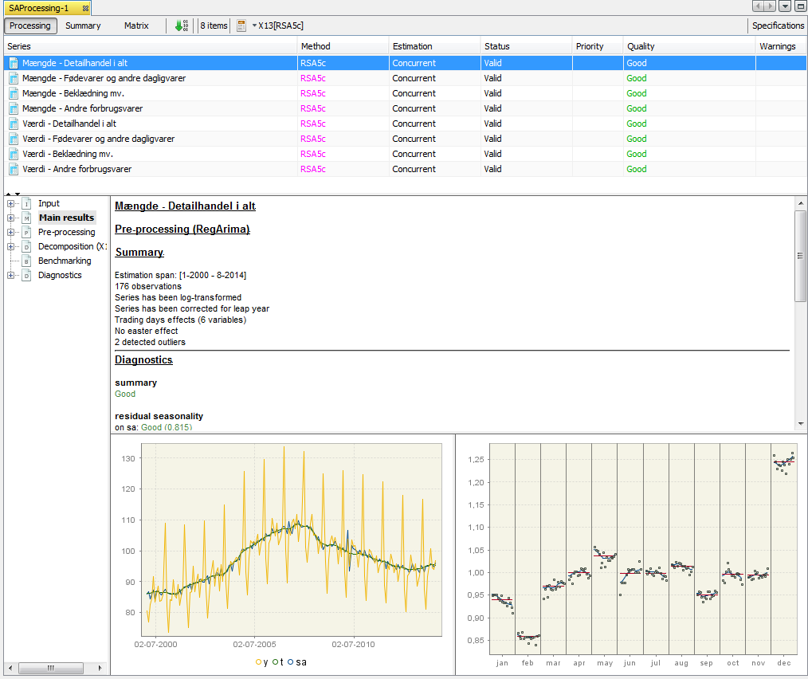

Checking the results
- Before you have a closer look at the quality measures, it’s a good idea to look at the selected model. It is found in the Pre-processing menu. The picture below shows the details of the model: The series has been log-transformed, and adjusted for leap year and trading days. No Easter effect has been detected, but two outliers have been identified (March and April 2010). The ARIMA model is (210)(011). Especially the two outliers in the Easter months are important. Further, not all days have a significant effect, but the collective trading day effect is significant, which is why the time series is adjusted for trading day effects. It is possible to specify regressor for the significant trading days. Alternatively, you can adjust for working days and check the results.
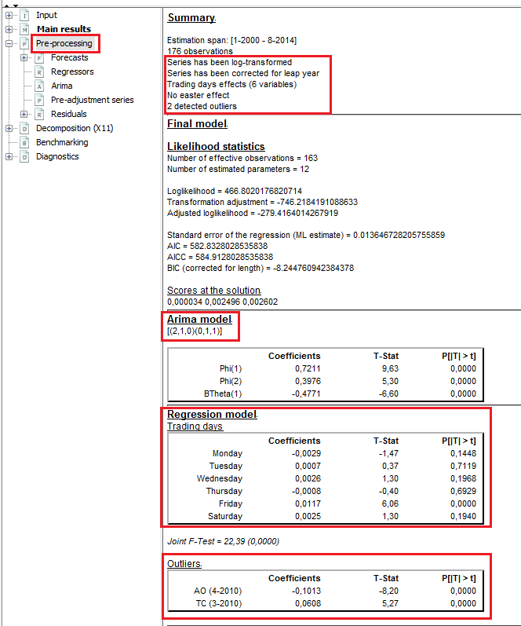

- The last thing to check before looking at the quality measures is whether there’s any significant seasonality in the time series. When it is as obvious as with this time series, checking for significant seasonality isn’t really necessary, but it is not always that clear. The tests for seasonality are found by clicking Diagnostics → Seasonality tests, and looking at the Original (transformed) series and Combined test. They do not always agree, but put together you get a good overview. The first image shows 6 different tests for seasonality, all green, meaning that significant seasonality has been detected by all 6 tests of the time series. The next is an image of the Combined seasonality test which is green, showing that significant seasonality is detected.
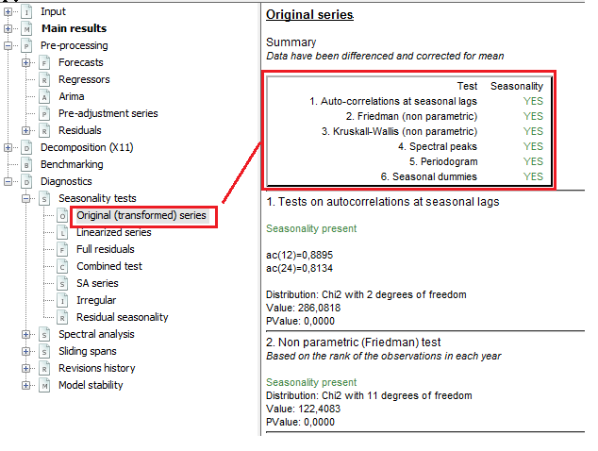
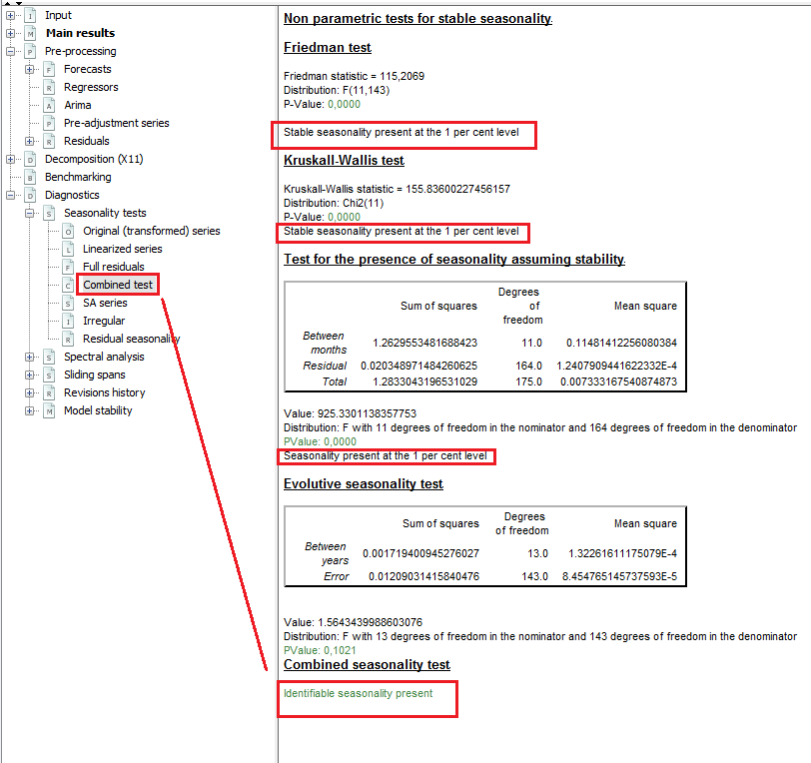

- Now, it’s time to check the quality measures of the series. This is done in the same order as they’re displayed in the Diagnostics page. All results are green, yellow or red depending on the test result. Green means that nothing problematic is detected by the test (e.g. lacking normality of residuals). If the tests are orange, it means that the result is uncertain. If they are red, you may need to do something about the problem. Before going through the details of the various tests we note that all tests are green. This shows (along with no exclamation marks in Warnings and the value Good in the quality column) that the model selected for the time series is quite good.
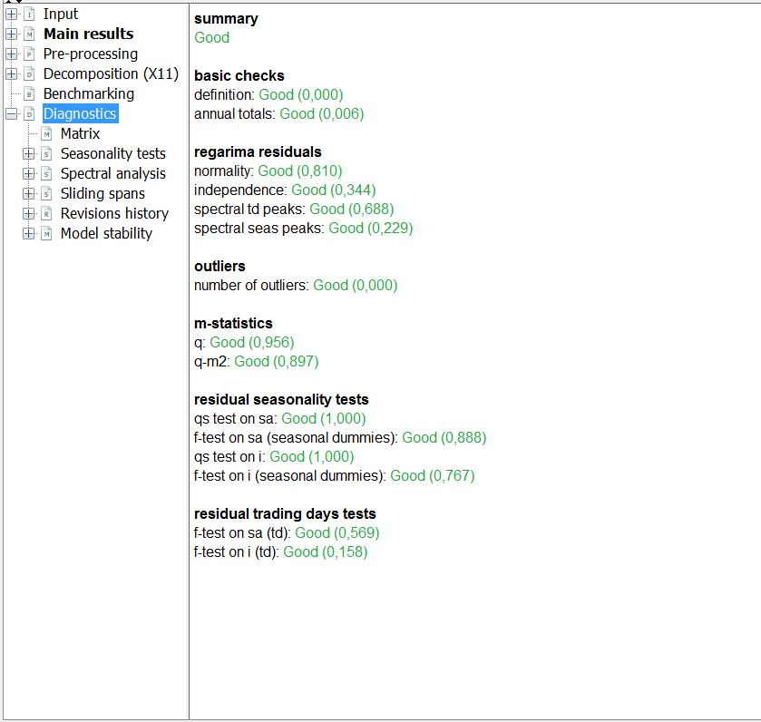
- Basic checks. The first one tests some basic relations between the various components of the time series. If the relations are not as expected, the test fails. This test should always be accepted, since a fail might mean that the seasonal adjustment process failed. The test is accepted. The second test compares annual totals of the raw time series with the seasonally adjusted time series. If there’s trading day and/or leap year adjustment, this test might fail, but without signifying a problem. If there’s no calendar adjustment, the test shouldn’t fail. This test is accepted, too.
- Regarima residuals. Four tests of the residuals of the regarima model. The two first are for the distribution, and are the most important of these four tests. Checks whether residuals from the regarima-model (model for the pre-adjusted time series) are normally distributed and independent. The last two checks for trading day (spectral td peaks) and seasonal peaks (spectral seas peaks) in residuals, i.e. whether seasonal or trading day effects is detected in the residuals. If some of these four tests fail, it might be hard to come up with one simple solution. It means that the model may not be suitable for the data. All four tests are accepted, so no problems with the residuals are detected.
- Outliers. Checks the numbers of outliers in relation to the length of the time series, if there is too many outliers above a specific threshold the test is not accepted. Test is accepted.
- M-statistics. We only see versions of the Q-test (combined test for all 11 M-tests, describing various properties of the various components). If Q is slightly higher than 1 it can still be acceptable, but if it is close to 2, it is problematic, and above 2 is almost always unacceptable. Values above 2 is often a sign that there’s no significant seasonality. Both tests are far below 1, so they’re green and accepted.
- Residual seasonality test. The first two tests test for significant seasonality in the seasonally adjusted time series. The last one tests for seasonality ion the irregular component. If there’s any seasonality left, it might mean that the seasonal pattern of the time series has changed over time, meaning that the seasonality is not captured by one model. Specifying two periods and carrying out different seasonal adjustments for them might be a solution to this. All three tests are green, so no residual seasonality has been detected in the time series or the irregular component.
- Residual trading days test. If the there are problems with the concerns the TD (trading day) test, it is possible to specify trading day effects manually.

- Most of the above tests can be found in various sub menus. The only other tests that we’ll look at in detail is the M and Q tests. These are found by selecting Decomposition (X11) → Quality measures → Summary. M7 is especially important, but all the M-tests give an idea as to whether there’s a problem with the seasonal adjustment. Some of these tests could fail, but if the values are just above 1, it might not be a problem. If a lot of them fail, even if they’re just above 1, or if some of them have very high values, it is more problematic. All tests are far below 1. M7 is in this case very acceptable, and so is the Q test (a combined test).
