**TWINNING PROJECT**

**Support to Development Process in the State Statistics Service of Ukraine with the Objective to Enhance its Capacity and Production**

**Ukraine**

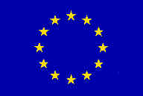

**MISSION REPORT**

**on**

**National accounts**

Mission carried out by Ms Charlotte Schiltz and Mr Jean-Pierre Berthier, INSEE (France)

23-25 mars 2015

Version: Draft

|  |  |  |
| --- | --- | --- |
|  |  |  |
|  |  |  |

***IPA 2009***

*Author’s name, address, e-mail (keep the relevant information)*

*Marie-Therese (alias Charlotte) Schiltz*

*INSEE*

*8 impasse des Fosses Rouges*

*92240 Malakoff*

*France*

*Tel: +33 1 40 92 17 85*

*Email: charlotte.schiltz2@gmail.com*

*Jean-Pierre Berthier*

*INSEE*

*10 place du Saint-Eynard*

*38000 Grenoble*

*France*

*Email: jean-pierreberthier@orange.fr*

**Table of contents**

Executive summary 4

1. General comments 4

2. Assessment and results 5

2.1 Treatment of some territories of the areas of Donetsk and Louhansk 5

2.2 Diffusion of data to Eurostat 8

2.3 The (national) diffusion of the national accounts 9

2.4 Satellite accounts 9

2.5 Global production 10

3 Conclusion and recommendations 10

Annex 1: Terms of Reference 12

Annex 2: Persons met 13

Annex 3: Diffusion of data to Eurostat (slideshow) 14

Annex 4: National diffusion of national accounts (slideshow) 16

Annex 5: Satellites accounts (slideshow) 18

Annex 6: Global production (slideshow) 19

**List of Abbreviations**

ToR Terms of Reference

SSSU State Statistics Service of Ukraine

INSEE Institut national de la statistique et des études économiques (National Institute for Statistics and Economic studies)

ESA European system of accounts

SNA System of national accounts

GDP Gross domestic product

GNI Gross national income

# Executive summary

This mission dealt with the following topics:

* Treatment of some territories of the areas of Donetsk and Louhansk
* Diffusion of data to Eurostat
* National diffusion of national accounts
* Satellite accounts
* Global output

The treatment of some territories of the areas of Donetsk and Louhansk constituted the priority of the SSSU; an important part of this mission has been devoted to advise the SSSU on this subject, mainly on the technical sides which present unusual difficulties. We also tried to give advices in order to facilitate documentation and the following communication on this subject, while leaving the SSSU totally free to decide of its future policy of external communication.

The presentation of the requirements of Eurostat as regards data transmission made it possible to the SSSU to become aware of the extent of work to be realized. The third mission, which could take place in the week from October 12th to October 16th, 2015, should look further into the examination on specific points that the SSU will determine by then. The question of “quality” could be approached on this occasion.

As regards national diffusion of the national accounts, the suggested approach should make it possible to SSSU to better think of its policy in this field.

The presentation of last international expansions in what regards the treatment of global production should help the SSSU to treat this difficult question with multiple aspects. It is in particular the case with regard to international subcontracting whose modification of treatment introduced by SCN2008 and SEC2010 must be taken into account.

# 1. General comments

This mission report was prepared within the framework of the Twinning Project ”Support to Development Process in the State Statistics Service of Ukraine with the Objective to Enhance its Capacity and Production”, funded by the European Union. It was the second mission devoted to the National Accounts component of the project. The mission took place in the SSSU (Kiev).

The concrete objectives of the mission were:

* To bring information to the SSSU on the diffusion of data to Eurostat by Member States; to allow SSSU to profit from the concrete experience of France.
* To bring a help to the SSSU in order to lay down a policy of (national) diffusion of national accounts.
* To bring information to the SSSU on satellite accounts; to allow the SSSU to profit from the experience of France in this field.
* To bring information on global production and its treatment in national accounts

The events in some territories of the areas of Donetsk and Louhansk, after those of Crimea at the time of the first mission, led the SSSU to firstly require examination on their treatment. Nearly two half-days were devoted to this difficult question, which has multiple aspects.

However, the topics initially forecasted in the program (cf above) have been examined as expected. But if the SSSU wishes it, the examination of the treatment of global production could be more thoroughly examined at the time of the third mission, which should take place during the week from October 12th to October 16th, 2015.

The experts would like to express their thanks to the SSSU team for its very kind welcome, and more generally to all the persons with which they have been in contact. A special thank has to be added, along with congratulations, to Lilian, our translator, for the quality of her work and her dedication to our mutual understanding.

The views and observations stated in this report are those of the experts and do not necessarily correspond to the views of EU, SSSU nor INSEE.

# 2. Assessment and results

The main themes approached during this mission were the following:

* Treatment of some territories of the areas of Donetsk and Louhansk
* Diffusion of data to Eurostat
* National diffusion of national accounts
* Satellite accounts
* Global output

## 2.1 Treatment of some territories of the areas of Donetsk and Louhansk

At present, Ukrainian accounts are established on an economic territory excluding Crimea. A new discussion is in hand for the taking into account of the events happening in some territories of the areas of Donetsk and Louhansk. The first half-day of the mission and part of the fourth were devoted to this difficult question.

Globally speaking, the experts advise to really document all numerical assumptions, by nature fragile, and the selected conceptual options. To decide to publish them in a transparent way or to keep them in-house is of course a choice of another nature which belongs to the SSSU. The main conclusions of the discussions, which are presented below take into account the need to avoid complicating too much the countable and statistical processing. They are of course only recommendations a priori and it will be up to the SSSU to adapt them if necessary at the time of their practical application.

The first point to be dealt with relates to the destructions: factories and dwellings, especially. One has to differentiate here flows accounts from assets accounts.

* Regarding flows accounts: the various aggregates, like production and added-value, will decrease because of disappearance of the productive assets which generate them, but there is no specific treatment to carry out.
* Regarding stocks accounts: the destruction of these assets must be transcribed in “other changes of volume”. This treatment also applies to destroyed large military equipment (in particular tanks).

Some assets of those zones, such as dwellings, will have seen their value decrease even without being destroyed. This fall constitutes a holding loss to record in the topic “holding gains and losses” of the revaluation accounts. It would be advisable to distinguish the specific loss due to this disturbed situation in the said territories from the real variation of the values, i.e. beyond the (positive or negative) general trend of prices (price of the GDP).

In addition, five specific points were examined:

* coal sold by separatists in Russia;
* the assets (productive equipment) transferred in Russia without counterpart;
* the Russian military equipment provided to the separatists;
* humanitarian aid given to the separatists;
* the agricultural lands which were mined.

One will examine successively these points.

**Sales of coal**

Part of the coal produced in this zone is sold by the separatists in Russia. They are thus exports. The question is that of knowing in which institutional sector can be classified the separatists, in order to affect the corresponding incomes to this sector. It is difficult to consider another ranking that “households”. But it will really be necessary to insulate (at least in-house – cf above) the corresponding amounts.

The creation of an “institutional quasi sub-sector” that one could call “Transactions with some territories of the areas of Donetsk and Louhansk - S149”, would be desirable in theory. It would be built on the same model that the account of the transactions with the rest of the world, and would be limited to the description of specific flows between Russia and the separatists. It would thus make it possible not to have to describe the whole of the accounts of this sector, in particular its relations with the rest of S14 (households), which would prove probably too complex, in particular because of humanitarian aid (cf below).

**Transfer of productive assets**

The productive equipment sent in Russia without financial counterpart is to be treated in “other changes of volume”. There is no specific treatment for the flows accounts. On the other hand, the cars of households which leave Ukraine towards Russia do not constitute a fixed asset because they are recorded in final consumption and not in gross fixed capital formation. They could thus appear only in a “for the record” entry, recalling the movements of durable goods. But those which were still in stock (in the trade offices, for example) are included in assets and must be treated as “other change of volume”.

**Supply of military equipment**

With regard to the military equipment provided free by Russia (tanks for example, recorded in gross fixed capital formation according to the international Manuals SEC 2010 – SNA 2008), we can say that there is transfer of economic property since the separatists sell the destroyed tanks at the cost of metal after having cut them out in scrap.

From an accounting point of view, it would seem logical to have a capital transfer, Gross Fixed Capital Formation and an increase in the stock of assets. However, the institutional sector in question being that of the households (cf above), there would be thus creation of a military Gross Fixed Capital Formation for the sector of the households, which is not envisaged by the ESA or the SNA and would introduce many difficulties (creation of a non-market service produced by households?).

Another solution would be to consider that this transaction is final consumption of household (and a current transfer). But neither this solution is in conformity with the ESA - SNA.

Of course, the very delicate questions of statistical evaluation add themselves to these conceptual problems. Vis-a-vis all these problems, the experts think most reasonable not to reflect the military equipment provided free by Russia in the accounts. The resale of scrap indicated above could be recorded in production (activity of recovery), export of scrap and income of the quasi institutional sub-sector S149. One will have to make sure that all these modifications will be treated in consistency with balance of payments.

**Humanitarian aid**

What is called “humanitarian aid” comprises in fact two phenomena’s:

* a true humanitarian aid given to the separatists who partly resell it. It is a transfer coming from the rest of the world (international cooperation if it comes from a state). As a counterpart, there is importation and consumption of the various provided products.
* military equipment: ammunition, fuel, uniforms. Insofar as large military equipment (tanks) provided would not be reflected, it seems logical not to recall this equipment either. Failing this, it would be necessary:
  + or to record a current transfer and a final consumption, which does not seem in conformity with ESA - SNA, in particular for the ammunition,
  + or to come to classification as intermediate consumption, which would once again draw the question of the creation of a non-market production of households.

None of these two solutions is thus satisfactory.

**Mined agricultural lands**

For mined agricultural lands, the analogy with a built ground on which the building was destroyed pushes us to recommend a treatment in holding loss.

## 2.2 Diffusion of data to Eurostat

The question of the transmissions of the national accounts to Eurostat was tackled under its various aspects, mainly:

* knowledge of what is required
* availability of the data
* respect of the deadlines
* their transmission
* documentation and controls
* needed means

A slide show, created for that purpose, was used as a support to this presentation. It appears as annex 3 of this report.

The following questions were especially discussed:

- taking into account illegal activities. ESA 2010 in its paragraph 1.79 states clearly that these activities must be included in national accounts since they have a significant importance in the concerned territory. For the European Union member states, Eurostat imposes inclusion in the accounts of prostitution, drug trafficking and smuggling of tobacco and alcohol. One will find below the link towards a document of INSEE specifying the obligation for the Member States to include an estimate of these activities in the notification of their Gross National Income.

<http://www.insee.fr/fr/indicateurs/cnat_annu/base_2010/methodologie/notification-rnb.pdf>

- the documentation of the link between corporations accounts and the corresponding aggregates of national accounts. One will find below the link towards the French document dealing with this question.

<http://www.insee.fr/fr/indicateurs/cnat_annu/base_2005/methodologie/PSB-base-2005.pdf>

See in particular appendix 4 and table 3 p.8

- development of input-outputs tables to be sent to Eurostat. One will find below the link towards the corresponding French document as well as the document related to the development of specifically French input-outputs tables, from which the tables for Eurostat are drawn up.

Specifically French SUT

<http://www.insee.fr/fr/indicateurs/cnat_annu/base_2000/documentation/methodologie/nb13.pdf>

SUT for Eurostat

<http://www.insee.fr/fr/indicateurs/cnat_annu/base_2000/documentation/methodologie/nb20.pdf>

In addition, the question of the distribution of the value added tax in connection with various types of fraud was discussed.

## 2.3 The (national) diffusion of the national accounts

The diffusion of the national accounts was approached starting from the questions which arise for the producer while laying down a policy of diffusion:

* Which users are aimed?
* Which support(s)?
* Free access / Tariffing
* What contents?
* Which after-sales service?
* Which means?

being specified that these various questions cannot be treated independently from/to each other.

A slide show, created for this occasion, was used as a support to this presentation. It appears as annex 4.

## 2.4 Satellite accounts

A general presentation of the philosophy of the satellite accounts, their statute and their articulation with the central framework of national accounts was made on the basis of the slide show which appears as annex 5 of this report. This presentation was based on the French experience, which made it possible to show the diversity and the interest of satellite accounts, but also the difficulties that their development and their maintenance must overcome. It also showed that these difficulties are strongly related to the specific organization of each country and the need for a coordination ensured by the department of national accounts.

In Ukraine, a small number of satellite accounts are carried out and others are in preparation. All are entrusted to the statistical units of the fields concerned (within the SSSU). The main problem seems to be the difficult question of the articulation with the central framework compiled by national accountants since the satellite accounts are established independently of the central framework.

## 2.5 Global production

The presentation of what it is agreed to call “global production” was carried out with the support of the slide show which appears as annex 6. This presentation refers to the general texts (SNA 2008 and ESA 2010) as well as the “Guide to measuring global production” that a “task force” of the Economic commission of the United Nations for Europe (UNECE) released recently.

Among the various aspects of this plentiful subject, directly related to globalization and the internationalization of groups of corporations, the presentation especially concentrated on international subcontracting (work under contract): the treatment of the corresponding flows “Net” constitutes a major innovation of the SNA 2008 and ESA 2010.

This difficult question was examined under its theoretical and statistical aspects (available sources, coherence between these sources, evaluation methods).

In connection with this question, “Special Purpose Entities (SPE)” were evoked. In addition, two other related topics were presented:

* the profiling of the groups of corporations;
* transfer prices.

If the SSSU thinks it is useful, the question of the international mobility of workers and the transfers of corresponding incomes could be approached at the time of the third mission.

# 3 Conclusion and recommendations

The treatment in national accounts of the events which occurred recently in part of the Ukrainian territory constituted a priority for the SSSU: we took the time to answer its expectation in a way as complete as possible. The general recommendations that we made are of two natures:

* Isolate as well as possible the modifications to the accounts required by these events, be it in the flows accounts or in the assets accounts. Document as well as possible the assumptions carried out, should they be conceptual or statistical. The degree of transparency in the diffusion of the accounts was also evoked, but it is more of a non-technical choice which belongs entirely to the Ukrainian part.
* Do not seek to reflect all the countable consequences of a complex and badly known reality, but do concentrate on the points considered to be essential. The examination carried out at the time of the mission shows that it is already a very delicate task.

The presentation of the requests of Eurostat as regards transmission of national accounts showed the SSSU the extent of the task. Now SSSU must examine in a detailed way the appendix B of the ESA regulation. Doing so, at the time of the third mission, we will be able to examine the more precise points that the SSSU wishes to examine. The other requirements of Eurostat could be also developed, in particular those which enter within the framework of the notification of the Gross National Income and the corresponding process of reserves. In parallel, quality standards, with the meaning that international organizations give to this term, could be discussed.

As regards national diffusion, the team of the SSSU well understood the approach suggested to lay down a policy of diffusion according to the context in which they find themselves. A priori, this subject does not call for a complement.

As for satellite accounts, we recommended to the SSSU to endeavour to improve their articulation with the central framework. This means a better coordination with the units in charge of the satellite accounts.

The changes in the treatment of international subcontracting brought by SNA 2008 and ESA 2010 must be set up. It is however a difficult question which will require a close cooperation especially with the team responsible of the compilation of Balance of payments. In a general way, moreover, a close cooperation with this service becomes increasingly necessary. Indeed, the last version of Handbook 6 of Balance of payments is in complete conformity with SNA 2008 – ESA 2010: to be coherent, these two systems must be elaborated in full coordination.

# Annex 1: Terms of Reference

for a short-term mission to the State Statistics Service of Ukraine

*Component 1 National accounts*

*Activity 1.3 "Improving the collection, processing and dissemination of statistical products"*

23–25March, 2015

**General information**

Statistics Denmark in partnership with INSEE France, Statistics Lithuania, Statistics Finland, Central Statistical Bureau of Latvia, is leading the EU-Twinning project on “Support to Development Process in the State Statistics Service of Ukraine with the Objective to Enhance its Capacity and Production” in Ukraine. The beneficiary is the State Statistics Service of Ukraine.

This activity is implemented under the Component 1 National accounts.

**Topics for discussion:**

1. Discussion of EU Regulations and Eurostat requirements concerning national accounts data, presentation formats of annual and quarterly sectorial accounts data, financial account, quarterly and annual national accounts, "resources-use" tables, regional accounts.
2. Discussion on the practical experience of the EU countries in preparing data for Eurostat and publication formats of national accounts indicators for users.
3. Discussion on linkages between the central system of accounts and analytical additions (satellite accounts) to SNA (auxiliary revenue statistics, other analytical developments, etc.).
4. Study the informational support to reflect the modern world economy changes in the national accounts (multinational corporations, transfer pricing, offshore institutional units to make financial transactions, use of intellectual property, mobility of labour force and incomes received from overseas).
5. Discuss ways to further improve the performance of Ukrainian SNA.

**Consultant and counterpart**

The mission will be carried out jointly by:

Mr Jean-Pierre Berthier (INSEE France),

Ms Marie-Therese Charlotte Schlitz (INSEE France)

The BC counterpart will be:

NIKITINA Irina, Director of Macroeconomic Statistics Department

MOSKVIN Oleksiy, Deputy Director of Macroeconomic Statistics Department

**Timing**

The mission will be carried out on 23-25 March in Kyiv, Ukraine

# Annex 2: Persons met

SSSU:

Irina NIKITINA, Director of Macroeconomic Statistics Department

Oleksiy MOSKVIN, Deputy Director of Macroeconomic Statistics Department

RTA Team:

Irina Bernstein , RTA

# Annex 3: Diffusion of data to Eurostat (slideshow)

 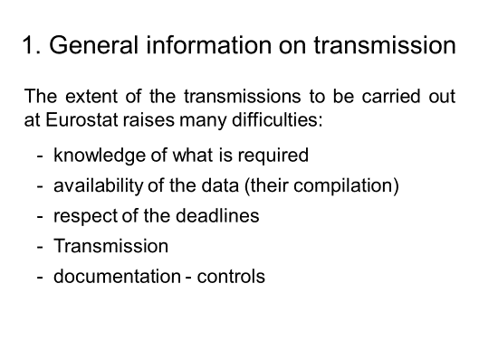

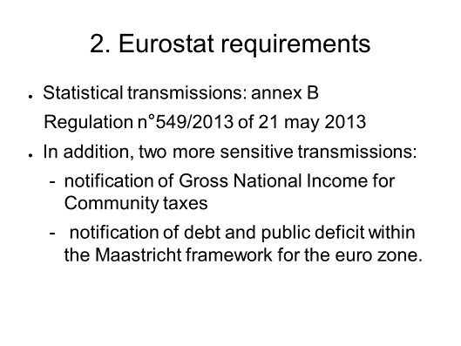 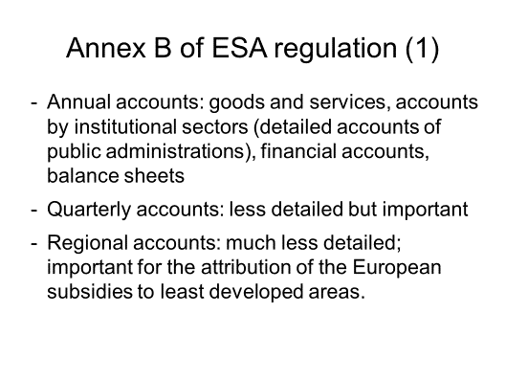

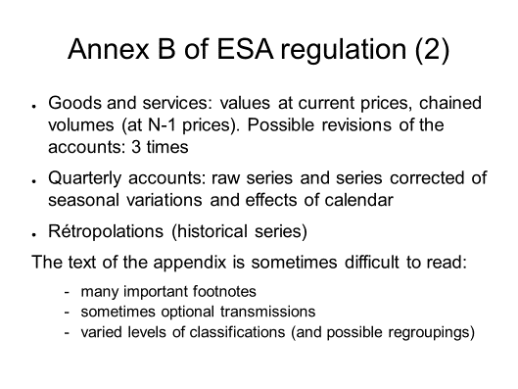 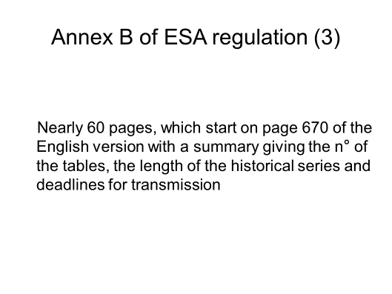

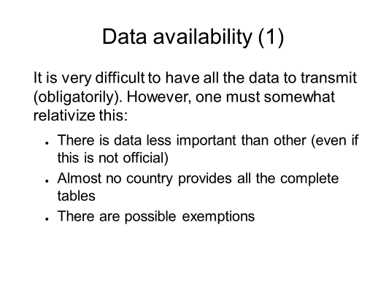 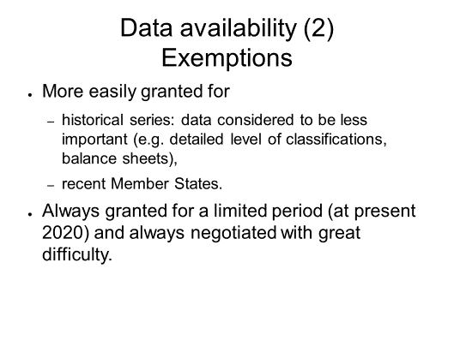

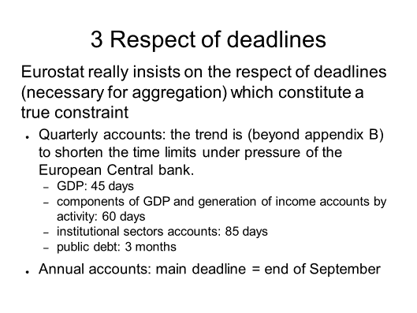 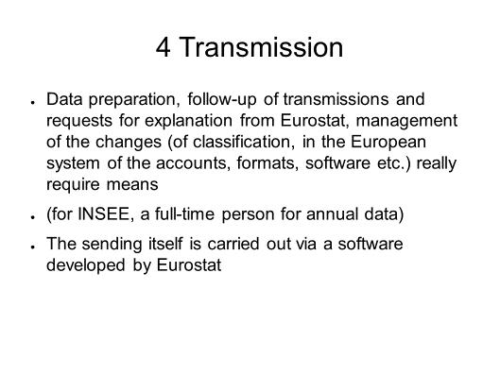

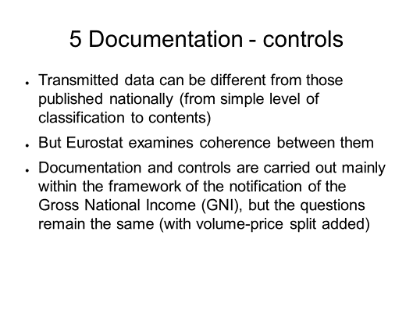 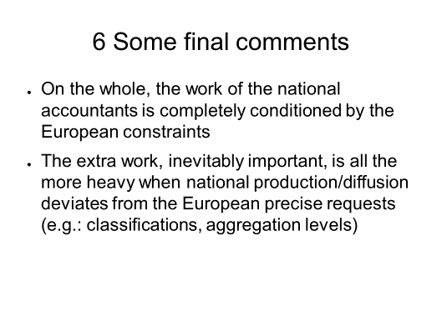

# Annex 4: National diffusion of national accounts (slideshow)

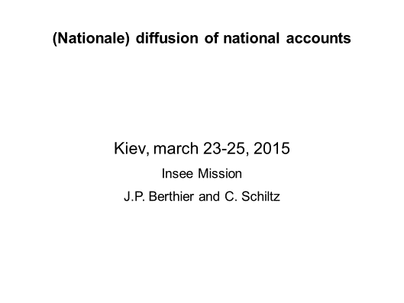 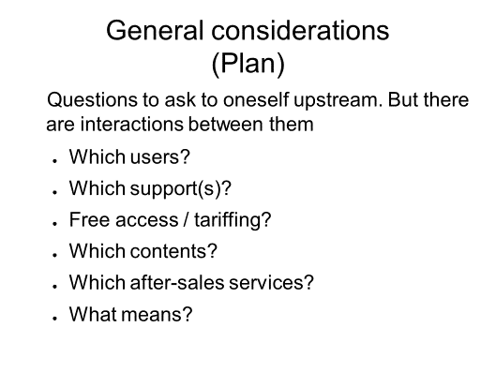

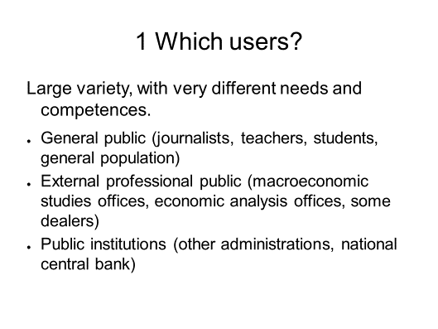 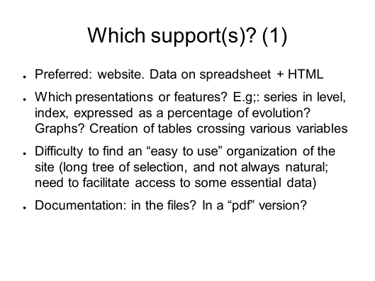

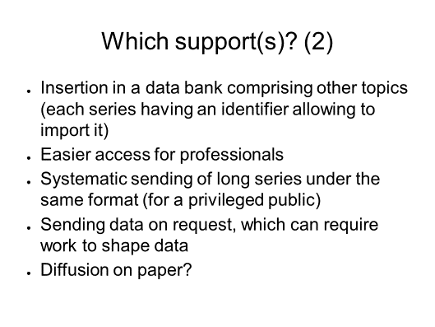 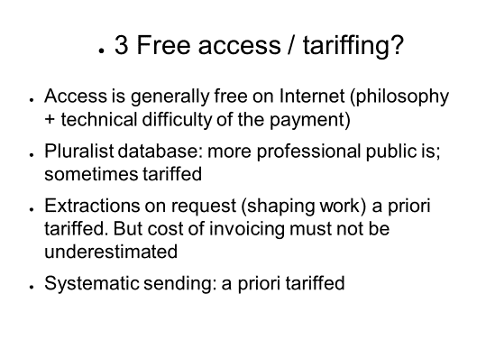

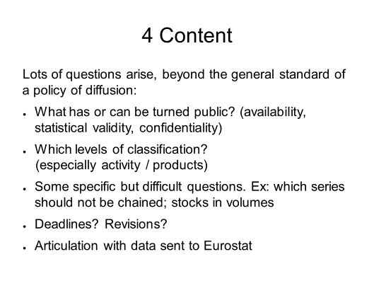 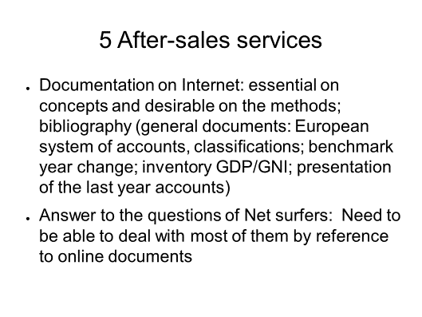

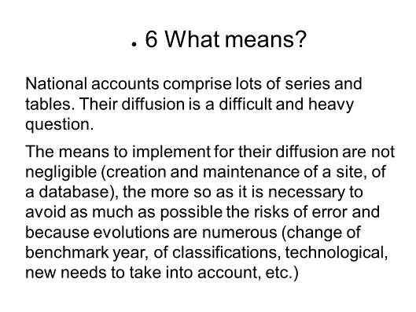

# Annex 5: Satellites accounts (slideshow)

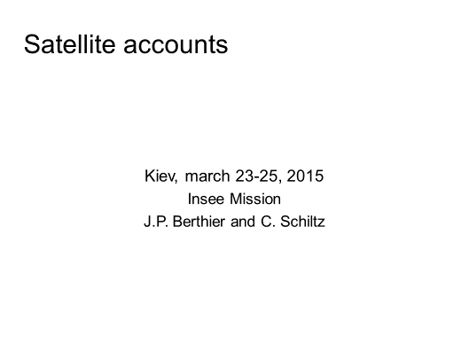 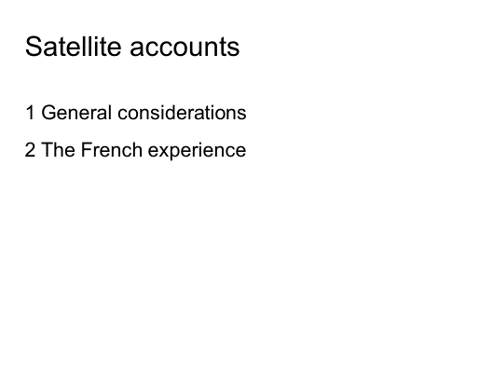

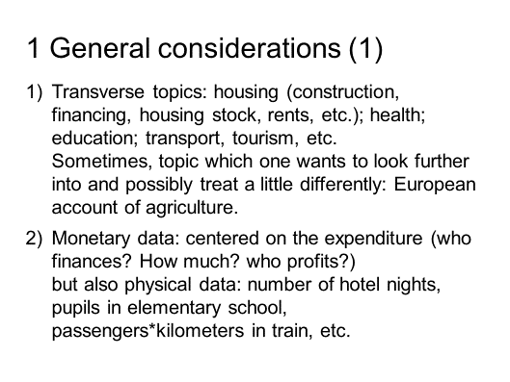 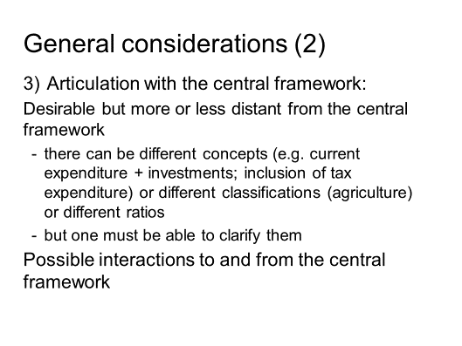

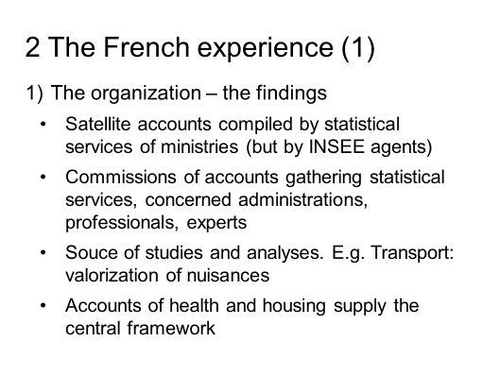 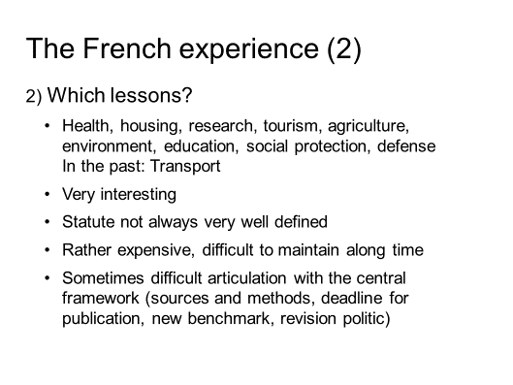

# Annex 6: Global production (slideshow)

