Exercise 7
The data file Exercise_7.xls has one sheet with the entire time series (National balance of payments), and one sheet in which observations are to be added one by one.
Do this exercise for a couple of observations (or all 4 extra observations at once).
- Import the data file Exercise_7.xls to JDemetra+ (as in exercise 2).
- Right-click on the path and select ”Add star”. This will save the path so that we don’t have to import the data file each time we open JDemetra+.
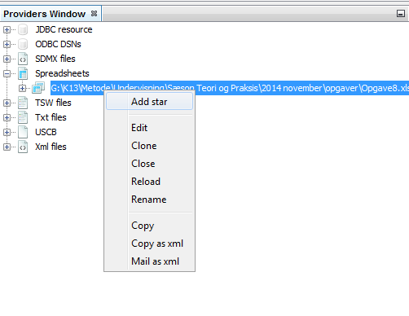
- Open two different Multi Processing windows. This will allow us to have one window for fixed models and one window for concurrent models (in order to compare). Run both seasonal adjustments from the sheet labelled “Run_This”. Use the seasonal adjustment specification file X13 – RSA5C as in exercise 2.
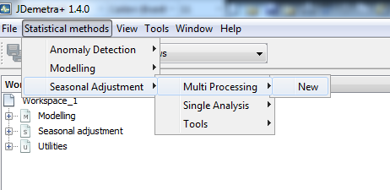
We are supposed to get the same result after the first round of seasonal adjustment – why?
- We can rename the seasonal adjustment processes to better distinguish them. This is done by right-clicking on them in the Workspace Window and selecting Rename
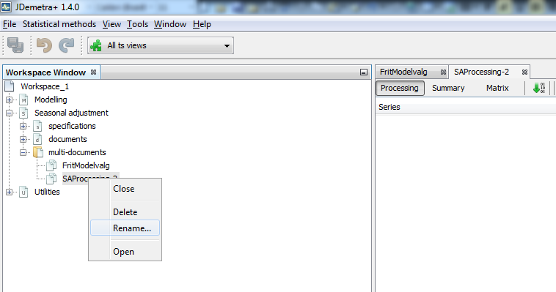
- Now, we need to save the output. Select Output from the drop down menu of the seasonal adjustment that you want to save.
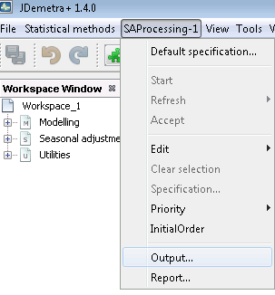
- Select the format that you want your output saved as:

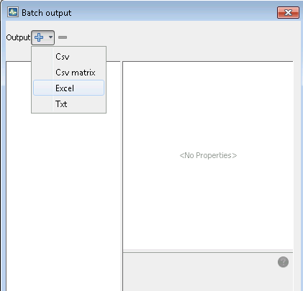
- Click Excel and then ”…” next to folder
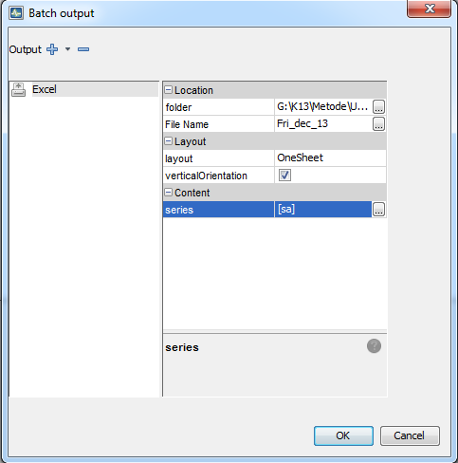
- Choose an output destination. You might want to name it something other than the default name “demetra”. This is done by clicking on “…” next to File Name. For this exercise you might want to name it something like “Free_model_choice_June_2020”, if it is the free (concurrent) model with endpoint June 2020.
- Under Layout you can choose how the output is saved, whether you want one sheet, one sheet per time series or one sheet per component.
- Next to series you can choose which components are to be exported. For this exercise, we only need the seasonally adjusted series sa.
- Both seasonal adjustments have to be saved
- In order to help you compare model choices, write down the automatically selected models each time a new seasonal adjustment is carried out. You might just get screen dumps and keep them in a word document.
- Now we need to save the workspace itself so that we can add new observations to the time series and update the seasonal adjustments. This is done by selecting Save Workspace As… from the drop down menu under File. You might want to save them to the folder that was automatically created when you saved the excel sheets (outputs).
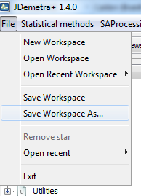
- When you want to update a time series, JDemetra+ needs to be closed down first.
- Add an observation from the sheet “Entire_series” to the sheet “Run_this” in Exercise_7.xls. Don’t forget to close the excel sheet afterwards.
- Open JDemetra+ and reopen your Workspace. It contains your two seasonal adjustment processes.
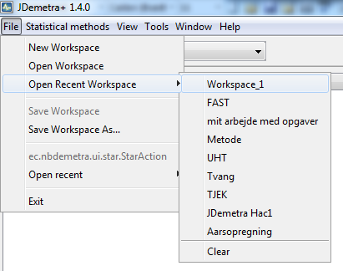
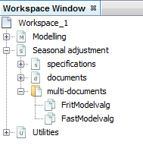
- Double-click on the two processes and double-click on the time series in the two processes.

- Now, we need to update the seasonal adjustment for the two processes so that the new observation is included. Select Concurrent for the free model choice and Fixed model for fixed model choice.
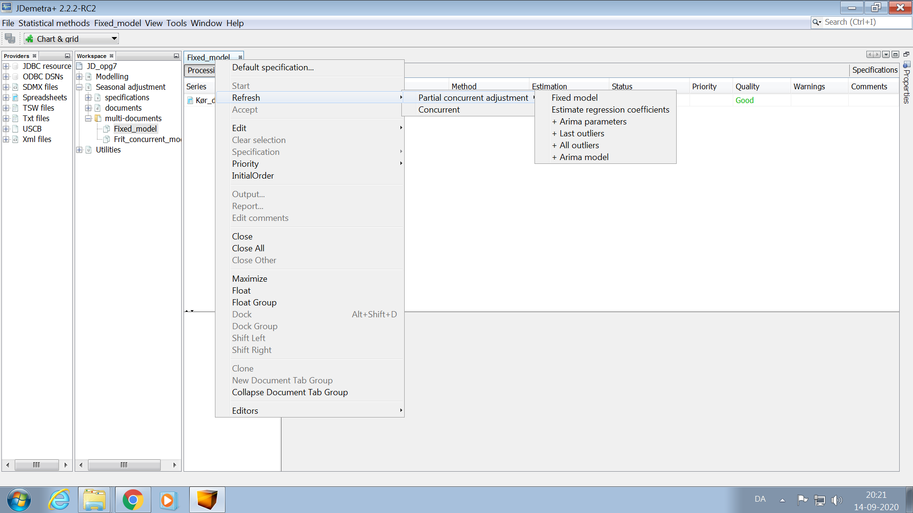

- Record the model types and notice the extra observation in pre-processing.
- In order not to have to save both time series each time we’ve added a new observation, we can drag the time series from Main results -> Table (select seasonally adjusted)

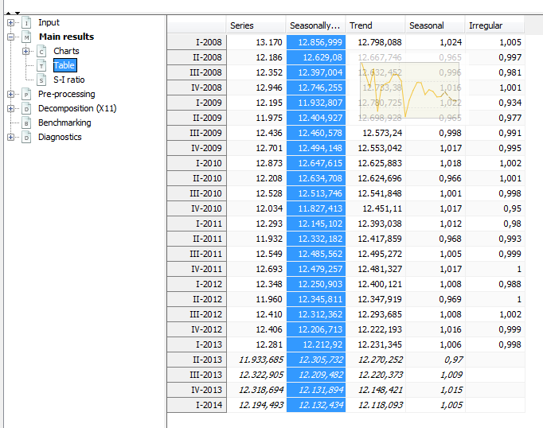
This can be dragged directly into an excel sheet. A date column will automatically be added. Delete the last 4 observations (they are forecasts).
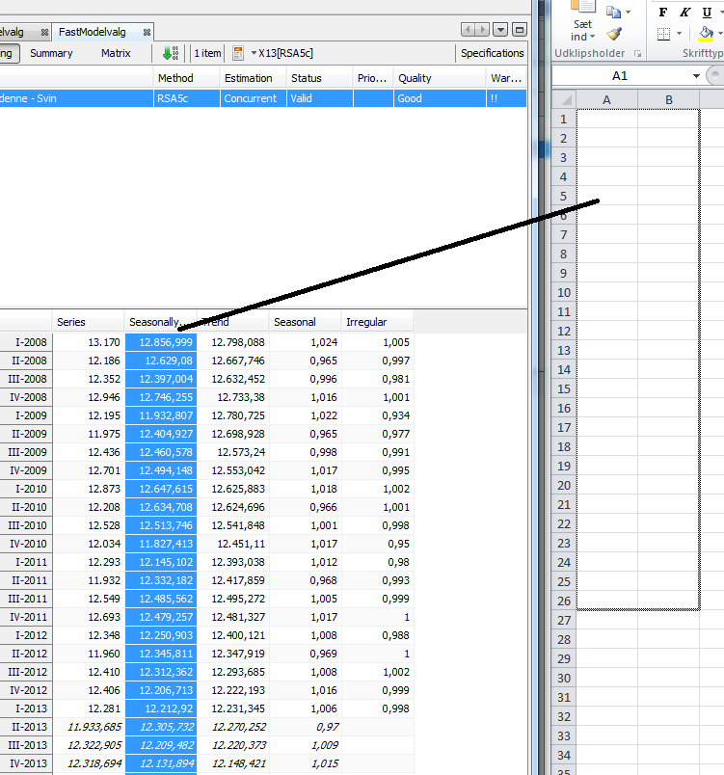
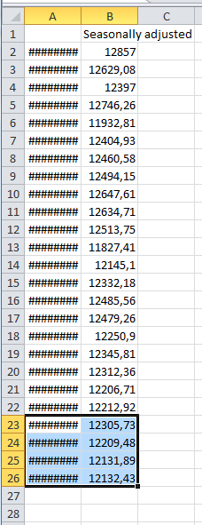
- Do this for the last extra observations
- Finally, compare revisions for the two different methods

