Exercise 4
- Run an automatic seasonal adjustment of the time series in the data file Exercise_4.xlsx (see exercise sheet from day one for instructions).
The Quality is ”Uncertain”. Why do you think that is?
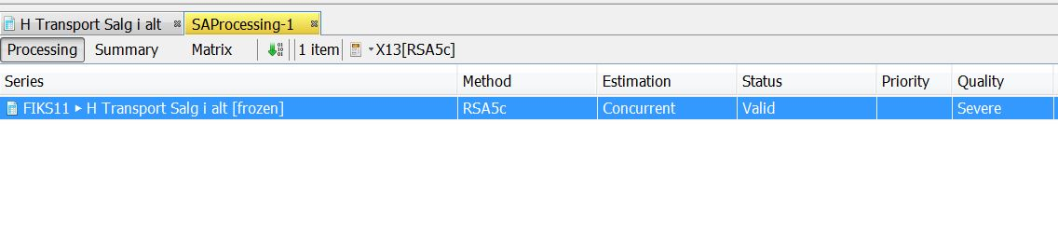
- Try decreasing the time span so that is starts in January 2013 by carrying out the following steps:
  - Select Specifications in the top right hand corner. A new window will appear.
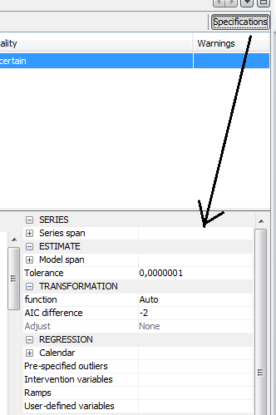
  - Select Series Span and type: From and change the start date to 2013-01-01
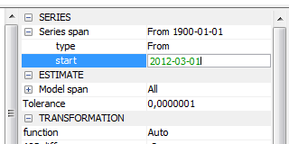
  - Click Apply in the bottom left corner of the “Specifications” window.
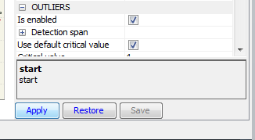
  - After clicking Apply, the new seasonal adjustment has been carried out. If you want to undo the changes, simply select Restore in the “Specifications” window. If you want to keep the new model, select Save. If you do not click Save, the model will revert to the original specifications when you leave the window.

Exercise 5
Calculate the specified moving averages of the series 1, -1, 1,-1, 1… You might want to use a spreadsheet.
(Calculate 3, 4 and 5 point moving averages of the first 16 observations. Plot the time series and the moving averages. Is there a difference between odd and even numbers of points? How many observations do the moving averages have (starting form 16 observations).

Exercise 6
- The time series p31 from “Quarterly Sector Accounts”. M7 = 0,110; Q = 0,169:
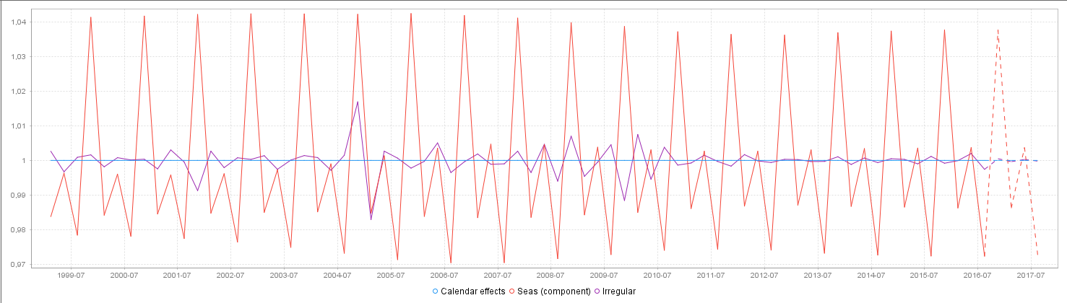
- The time series B1G_1 from “Quarterly Sector Accounts”. M7 = 2,561; Q = 1,422:
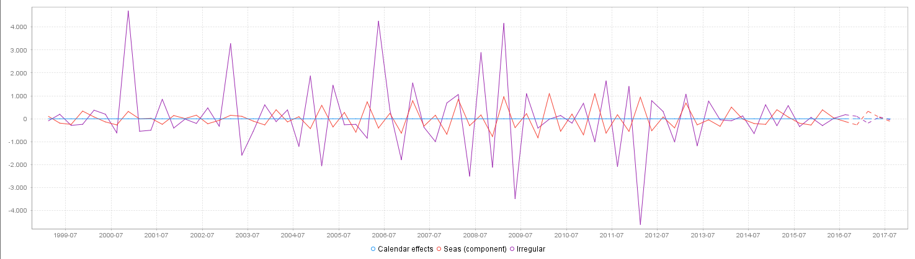
- The time series k2529o from IPO. M7 = 0,234; Q = 0,175
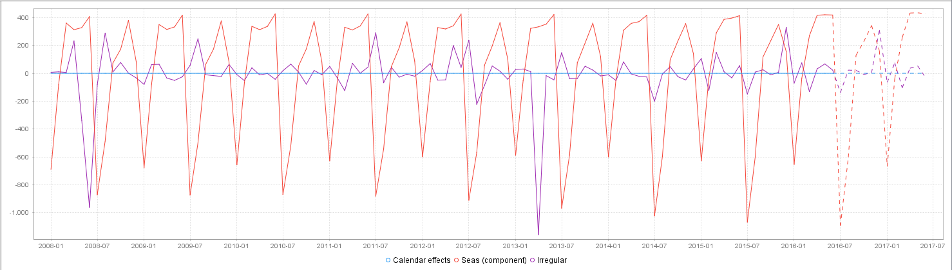

- The time series ZIVU from ”Employment of wage-earners”. M7 = 1,264; Q = 1,044:
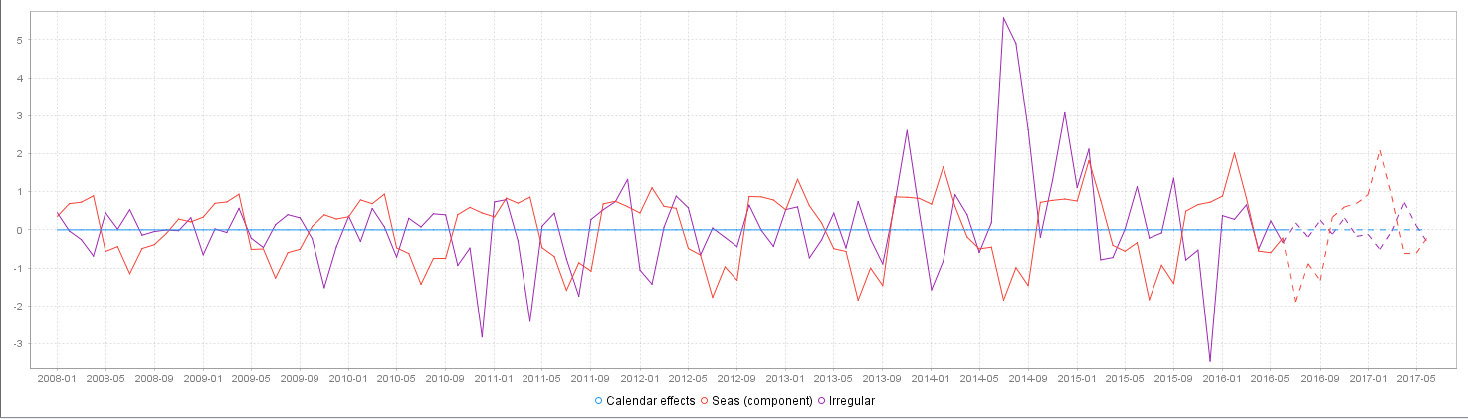
- The time series k0099u from IPO. M7 = 1,029; Q = 1,140.
