INFORMATION FOR WRITERS
- Papers should not be longer than 6 pages + 2 pages for the title page and a list of reference
- All papers must be written in English
- All papers must be sent in Microsoft Word format file (*.doc or *.docx).
- The font type is Arial.
- In the title of the papers please use 24 pts and centre the title. In the main text please use 12 pts.
- Main headings should be in bold, subheadings should be in Italics.
- Please use 1.5 line spacing, paragraph line spacing 6 pts before, 0 pt after.
- In abstracts, footnotes, signatures of figure etc. please use 10 pts.
- Sections should be consecutively numbered by Arabic numerals.
- Equations should be centered, 6 points space above and below the text.
- Tables, figures and cartograms should be included directly in the files you submit. They should be at high resolution.

Title of paper
Name, Affiliation, E-mail
Name, Affiliation, E-mail

Abstract.
The abstract should include no more than 300 words. Remember to write the abstract in English. Please avoid jargon and explain all abbreviations. Try to use short and simple sentences. A good abstract underlines the results, findings and observations. Try to explain why the topic and the results are relevant: How do the results respond to user needs or strategically relevant objectives? What kind of impact have the results had on your work? Can the results be scaled-up or copied and implemented in other countries? What can the statistical community learn from your experiences? Please end your abstract with 1-5 key words.
Keywords: lorem, ipsum, dolor, sit, amet
- Population statistics
  - introduction
Population statistics are a crucial tool for understanding human societies, as they map everything from birth rates and mortality to migration patterns and age distribution. By analyzing this data, researchers and policymakers can predict future needs for infrastructure, healthcare, and education. For example, statistics in many Western countries reveal a trend toward an aging population, which puts pressure on the labor market and pension systems. Overall, population statistics serve as a demographic compass that makes it possible to navigate global challenges such as urbanization and resource distribution.

Figure 1: Production index, seasonally adjusted
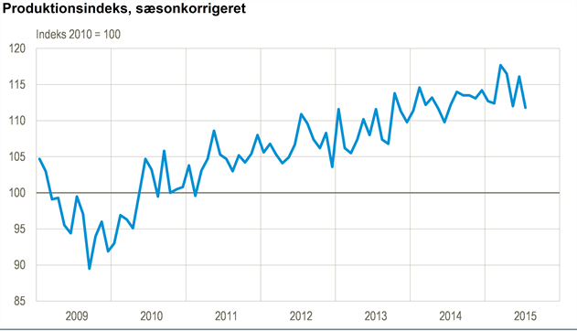

Overall, population statistics serve as a demographic compass that makes it possible to navigate global challenges such as urbanization and resource distribution.
$${\left(x+a\right)}^{n}=\sum_{k=0}^{n}{\left({n \atop k}\right)x^{k}a^{n-k}}$$
- Headline 2
- Headline 3
- …..
- Appendix: List of references

